**INDEX**

|  |  |  |
| --- | --- | --- |
| **Sr.No** | **Practical** | **Page No** |
| **1.** | **Building ASP.NET Core MVC Application** |  |
| **2.** | **Building ASP.NET Core REST API** |  |
| **3.** | **Working with Docker , Docker Commands , Docker Image & Containers** |  |
| **4.** | **Installing software package on Docker , Working with Docker Volumes & Network** |  |
| **5.** | **Working with Docker Swarm.** |  |
| **6.** | **Working with Circle CI for continuous integration.** |  |
| **7.** | **Creating Microservice with ASP.NET Core.** |  |
| **8.** | **Working with Kubernetes.** |  |
| **9.** | **Creating Backing Service with ASP.NET Core.** |  |

**MA practical 1:**

**Building ASP.NET Core MVC Application**

**Step 1: Create the Folder Name it as MVC**

**Step 2: Open CMD Prompt**

**Step 3 : To Create the MVC Project Run**

**dotnet new mvc --auth none**

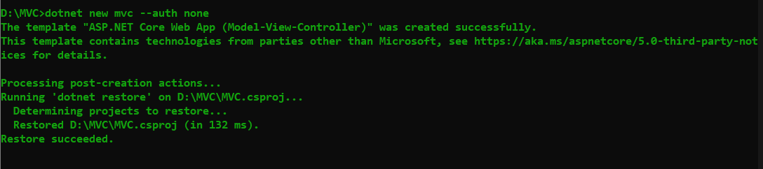

**Step 4: Edit the Controller File “ HomeController.cs” to return the string “**Hello Vishal, this is My First ASP.Net MVC Practical “

**Step 5: Run the command in the CMD “ dotnet run “**

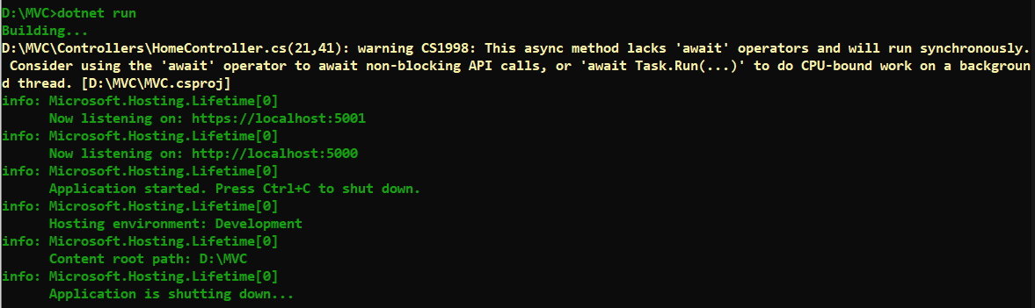

**Step 6: Now open the browser and type** [**https://localhost:5001/**](https://localhost:5001/)

**And see the output .**

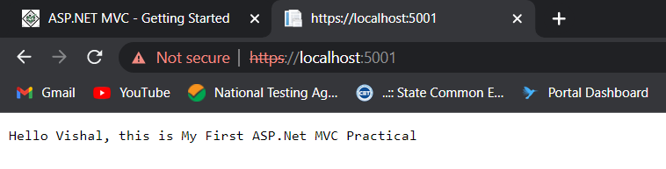

**Step 7 : Now press the Crtl+C in CMD to stop the**  **CMD .**

**Step 8: Go to models folder and add new file StockQuote.cs to it with following content**

using System;

namespace MVC.Models

{

public class StockQuote

{ public string Symbol {get;set;}

public int Price{get;set;}

}

}

**Step 9 :** Now Add View to folder then home folder in it and modify index.cshtml file to match following

@{

ViewData["Title"] = "Home Page";

}

<div>

Symbol: @Model.Symbol <br/>

Price: $@Model.Price <br/>

</div>

**Step 10:** Now modify HomeController.cs file to match following:

using System;

using System.Collections.Generic;

using System.Diagnostics;

using System.Linq;

using System.Threading.Tasks;

using Microsoft.AspNetCore.Mvc;

using Microsoft.Extensions.Logging;

using MVC.Models;

namespace MVC.Controllers

{

public class HomeController : Controller

{

public async Task<IActionResult> Index()

{

var model = new StockQuote { Symbol = "Hello", Price = 50000 };

return View(model);

}

//{

// private readonly ILogger<HomeController> \_logger;

// public HomeController(ILogger<HomeController> logger)

// {

// \_logger = logger;

// }

// public IActionResult Index()

// {

// return View();

// }

// public IActionResult Privacy()

// {

// return View();

// }

// [ResponseCache(Duration = 0, Location = ResponseCacheLocation.None, NoStore = true)]

// public IActionResult Error()

// {

// return View(new ErrorViewModel { RequestId = Activity.Current?.Id ?? HttpContext.TraceIdentifier });

// }

}

}

**Step 11 :** Now run the project using

dotnet run

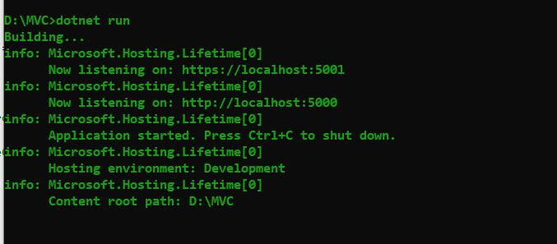

**Step 12 :** Now go back to browser and refresh to get modified view response

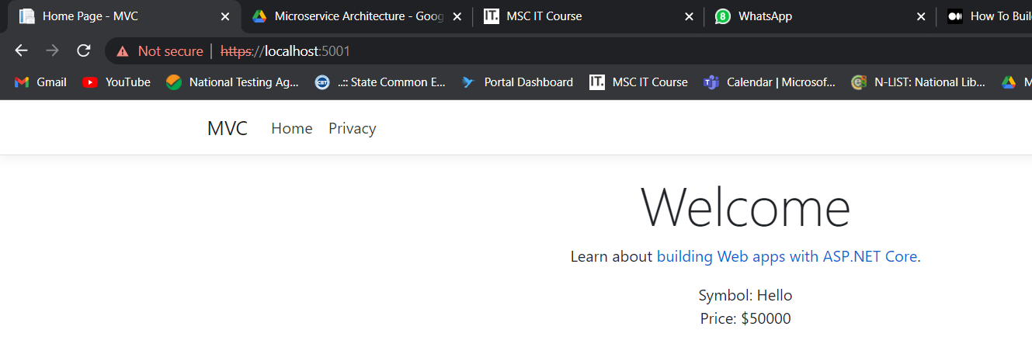

**Practical N0 : 2**

**Building ASP.NET Core REST API**

**Step 1 : Creating a web API project**

First, open**File -> New-> Project**in Visual Studio:

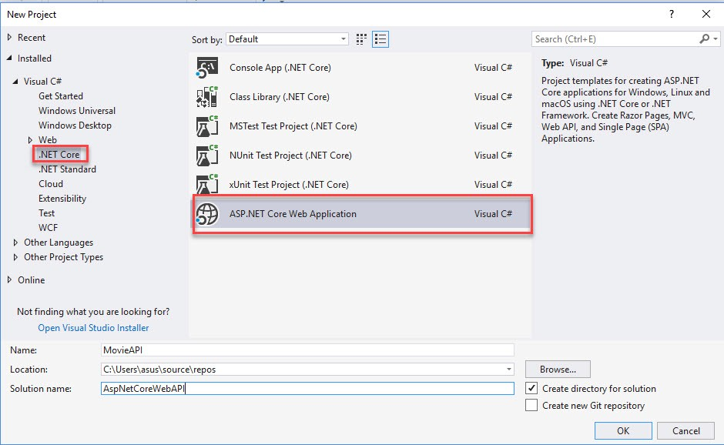

Step 2 : Select **ASP.NET Core Web Application**, give a name to the project and the solution and then click OK.

At this point we have a starter project as follows:

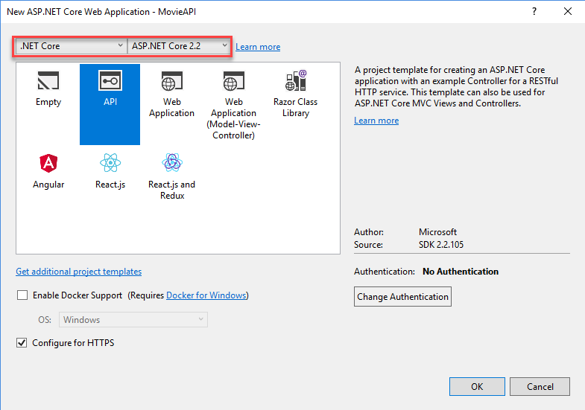

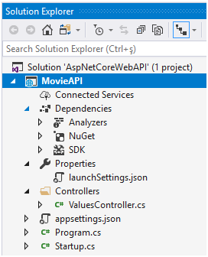

Step 3 : From the Startup.cs that MVC (Model-View-Controller) service is added to and used in the starter project:

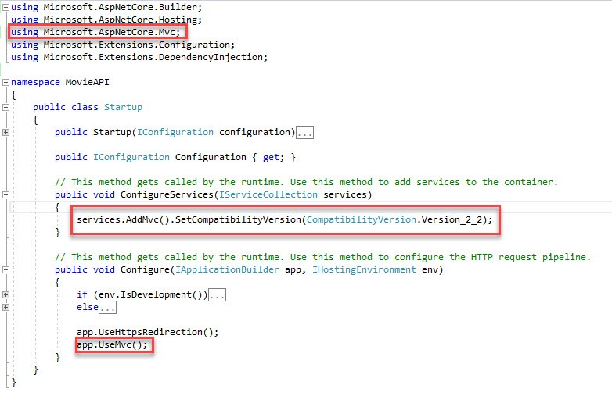

Step 4 : Now, let’s run the app (Ctrl+F5) and see the default output. I will use IIS Express as the web server and Mozilla Firefox as the web browser:

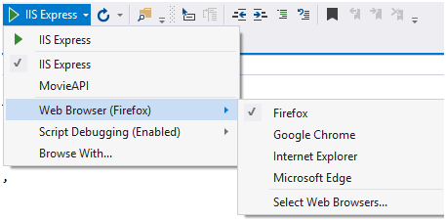

After running, we get the following page:

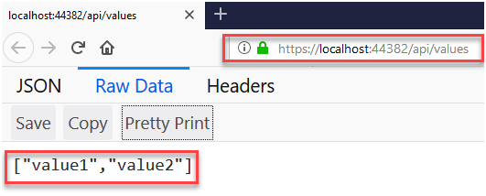

Default URL https://localhost:{port}/api/values comes from the launchUrl property in the Properties\launchSettings.json:

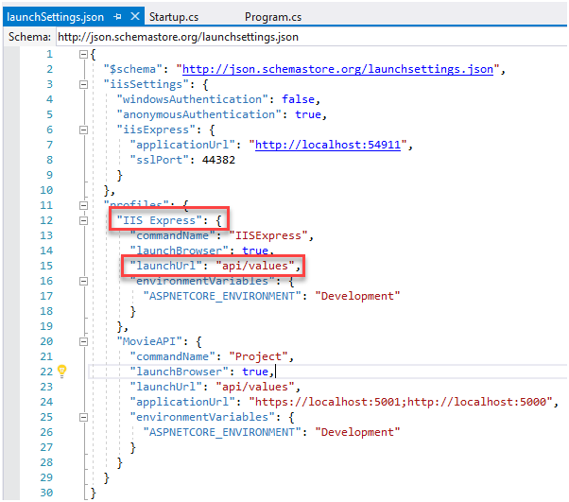

And the values that we see in the browser come from the Get method of the ValuesController :

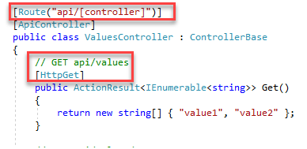

**Step 5 : Adding a Model**

*In*Solution Explorer*, right-click the project.* ***Select*Add > New Folder *and name the folder*Models*.***

*Then* ***right-click*** *the*Models *folder and select***Add->Class**. *Name the class***Movie.cs** *and click* ***Add.***

*Next, add the following properties to the class.*

using System;

using System.ComponentModel.DataAnnotations;

namespace MovieAPI.Models

{

public class Movie

{

public int Id { get; set; }

[StringLength(60, MinimumLength = 3)]

public string Title { get; set; }

[StringLength(30)]

[RegularExpression(@"^[A-Z]+[a-zA-Z""'\s-]\*$")]

public string Genre { get; set; }

[DataType(DataType.Date)]

public DateTime ReleaseDate { get; set; }

}

}

**Step 6 :** Right-click the *Controllers*folder and select ***Add -> Controller***

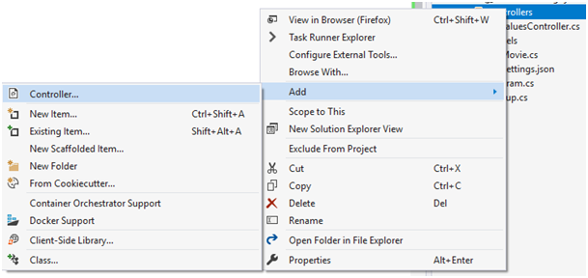

**Step 7 :** In the *Add Scaffold* dialog, select *API Controller with actions, using Entity Framework* and click Add.

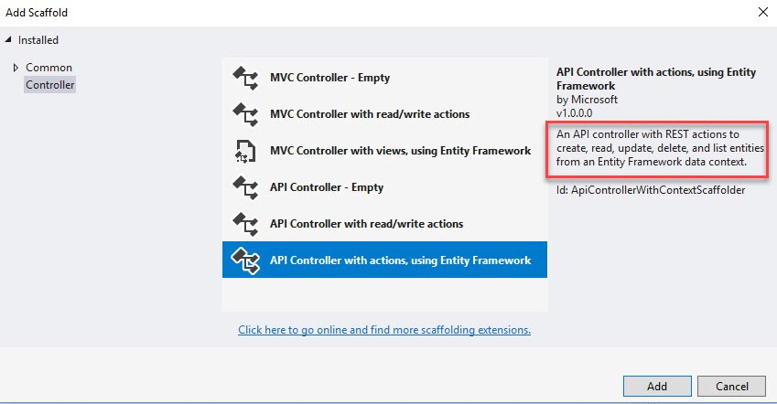

**Step 8 :** In the next dialog, select *Movie* from the *Model class* drop-down list and then click + sign to add the *Data context class*. You can keep the default for the names and then select Add.

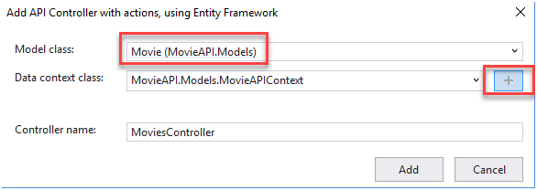

**Step 9 :** We will now examine what Visual Studio added to our project automatically as the result of scaffolding:

1. Controller class -> *Controllers\MoviesController.cs*

The following methods are the action methods of the *MoviesController*:

GetMovie (GET method)

PostMovie (POST method)

PutMovie (PUT method)

DeleteMovie (DELETE method)

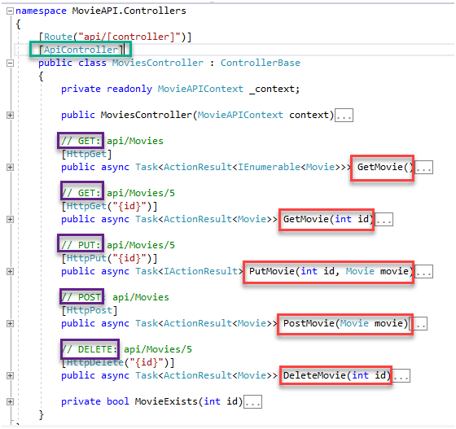

**2. EF Core database context class -> Data\MovieAPIContext.cs**

The MovieAPIContext coordinates EF Core functionality (Create, Read, Update, Delete, etc.) for the Movie model. The MovieAPIContext is from derived  [Microsoft.EntityFrameworkCore.DbContext](https://docs.microsoft.com/en-us/dotnet/api/microsoft.entityframeworkcore.dbcontext). The data context specifies which entities are included in the data model:

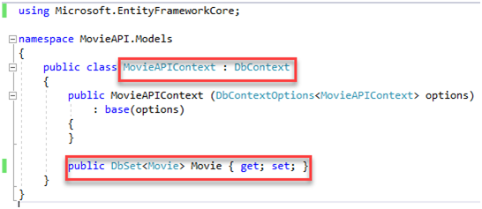

The name of the connection string is passed into the context by calling a method on a DbContextOptions object. For local development, the [ASP.NET Core configuration system](https://docs.microsoft.com/en-us/aspnet/core/fundamentals/configuration/index?view=aspnetcore-2.2) reads the connection string from the **appsettings.json** file:

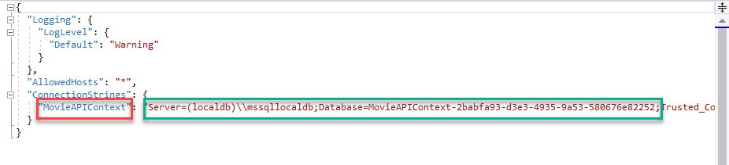

The scaffolding tool registered the DB context (MovieAPIContext) with the DI container in the ConfigureServices method of *Startup.cs* as below:

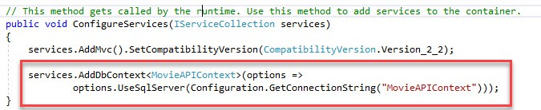

In the *MoviesController*, the constructor uses dependency injection to inject the database context (MovieAPIContext) into the controller:

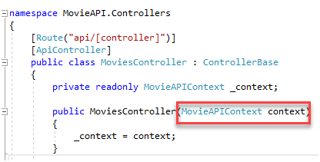

**Step 10 : Creating Database using Migrations**

Now, we will create the database using the EF Core [Migrations](https://docs.microsoft.com/en-us/aspnet/core/data/ef-mvc/migrations?view=aspnetcore-2.2) feature.

First, we will add an initial Migration.

Open ***Tools -> NuGet Package Manager > Package Manager Console(PMC)*** and run the following command in the PMC:

Add-Migration Initial

The Add-Migration command generates code to create the initial database schema which is based on the model specified in the *MovieAPIContext*class. The *Initial*argument is the migration name and any name can be used.

After running the command, a migration file is created under the *Migrations* folder:

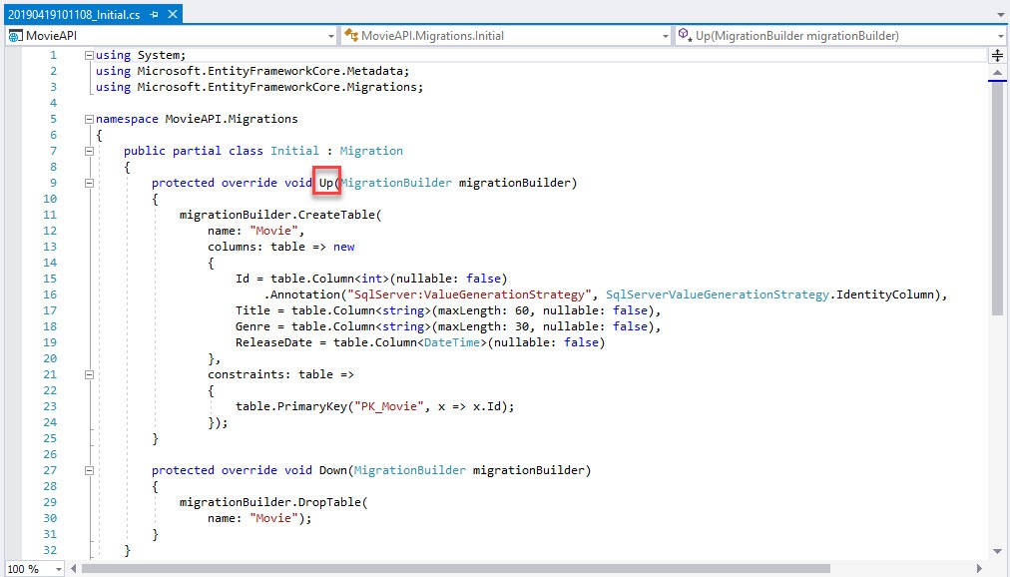

**Step 11 :** As the next step, run the following command in the PMC: Update-Database

The Update-Database command runs the Up method in the *Migrations/{time-stamp}\_Initial.cs* file, which creates the database.

Now, we will check the database created. Open *View -> SQL Server Object Explorer.*

You will see the newly created database under the following path:

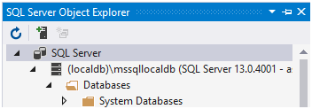

as below:

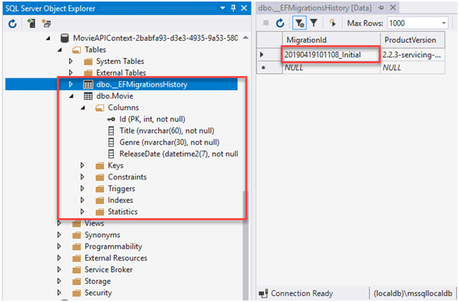

**Step 12 :** As you see, the **Movie table** and the **migration history table** are created automatically. Then a record is inserted to the migration history table to show the executed migrations on the database.

**GET Method**

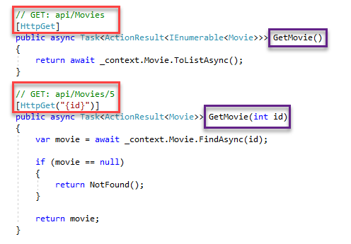

MoviesController.cs

**Step 13 : Testing the GetMovie Method**

Now we will test these endpoints. Before that, let’s insert some movie records to our table.

Go to the **SQL Server Object Explorer** and right-click the **Movie** table and select **View Data**:

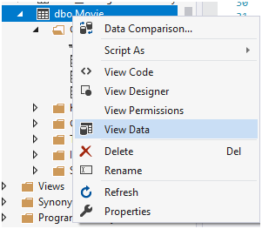

**Step 14 :** Then add some movie records manually to the table:

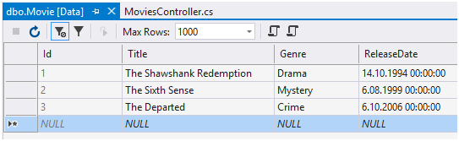

**Step 15 :** Now, we can run the application. Start the application and enter https://localhost:{port}/api/movies in the browser. We get the following JSON result:

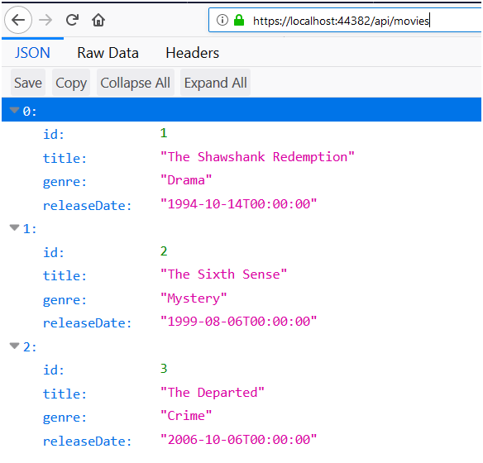

Screenshot of the browser

**Step 16 :** This shows all of the movies in the application.

To test the second GET endpoint, enter https://localhost:{port}/api/movies/2 in the browser which brings the movie with Id = 2 as below:

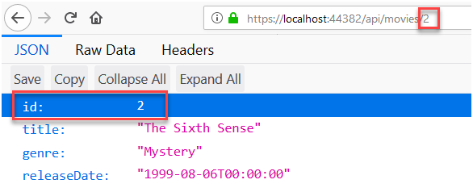

**Step 17 :** If no item matches the requested ID, the method returns a **404 [NotFound](https://docs.microsoft.com/en-us/dotnet/api/microsoft.aspnetcore.mvc.controllerbase.notfound" \t "_blank)** error code.

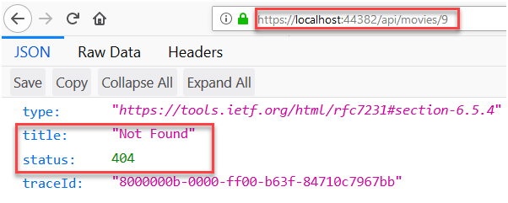

For convenience, you can change **launchSettings.json** as follows so that you won’t need to enter https://localhost:{port}/api/movies to the browser every time you launch the application.

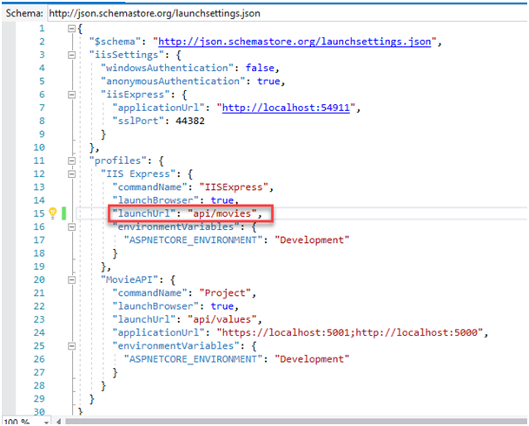

launchSettings.json

**Step 18 : POST Method**

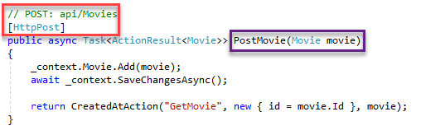

MoviesController.cs

**Step 19 : Testing the PostMovie Method**

Now, we will test this endpoint using[**Postman**](https://www.getpostman.com/downloads/) as our API client.

Start the application and start Postman.

Before testing the POST method, let’s use the GET method and see the result that we saw in the browser in the previous method.

Select **GET** method and enter the URL as below (after changing your port number) and then click **Send**. As the result, we get status code **200** and the JSON response as below:

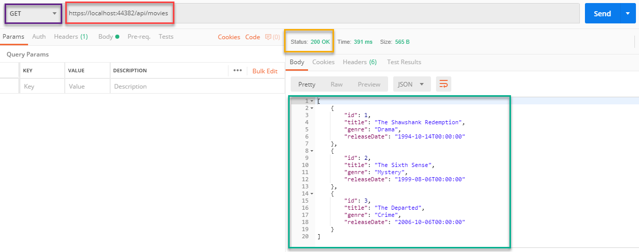

Postman screenshot

**Step 20 :** To test the POST method,

Set the HTTP method to **POST**.

Enter the URL (https://localhost:{port}/api/movies)

**Step 21 :** Select the **Body** tab. Select the **raw** radio button and set the type to **JSON (application/json)** in this tab.

In the request body, enter JSON for a movie record(You can get this part from the JSON response that we got in the above test and change it. Do not forget to remove the Id part.)

**Step 22 :** Click **Send**.

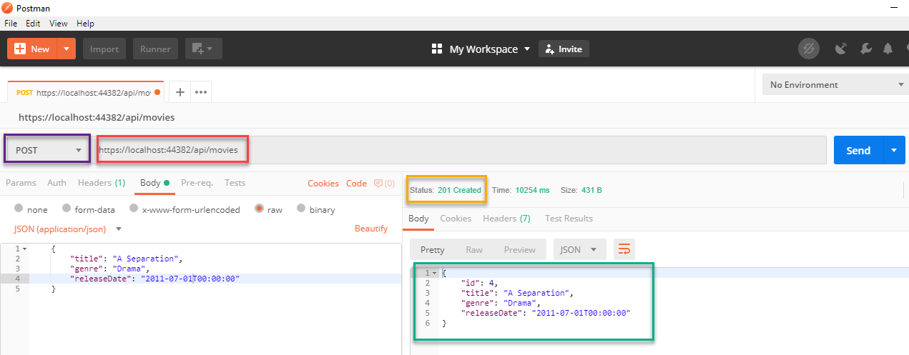

Postman screenshot

**Step 22 :** If you select the **Headers**tab of the response pane, you will see the **location URI** of the newly created movie record.

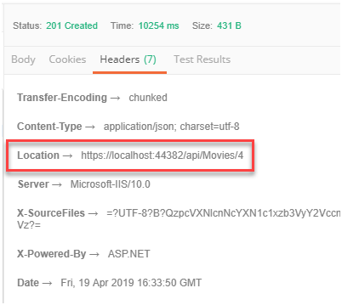

**Step 23 :** You can test this URI after selecting GET method and pasting the URI in the Postman or directly from the browser:

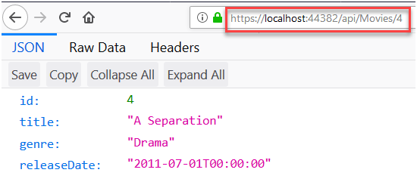

Screenshot of the browser

**Step 24 :** Also we can check this record from the **Movie**table in our database:

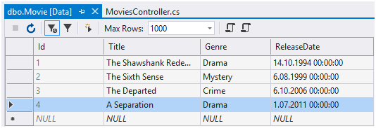

**Step 25 : Validations Test**

As you may remember, we used data annotations for validation purposes in our model class:

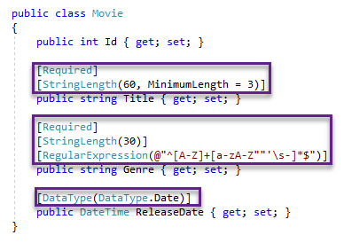

**Step 26 :** 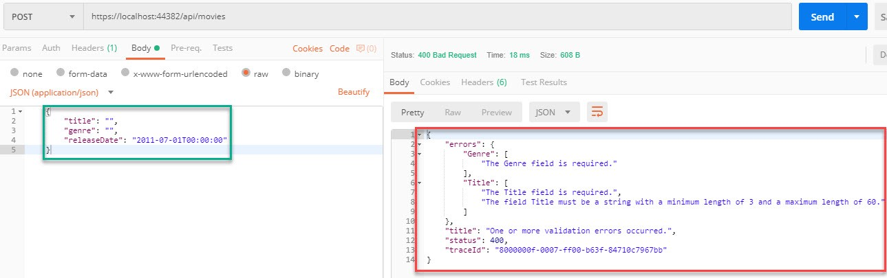We can see the effect of these annotations when we try to post an invalid record from Postman as below:

Postman screenshot

**Step 27 : PUT Method**

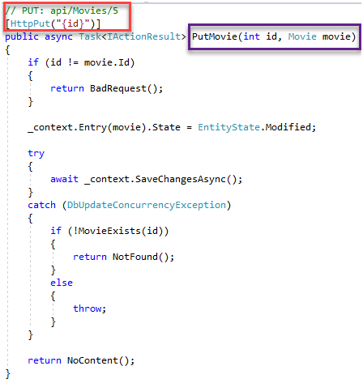

MoviesController.cs

**Step 28 : Testing the PutMovie Method**

Start the application and start Postman.

Set the HTTP method to **PUT**.

Enter the URL (https://localhost:{port}/api/movies/3)

**Step 29 :** Select the **Body** tab. Select the **raw** radio button and set the type to **JSON (application/json)** in this tab.

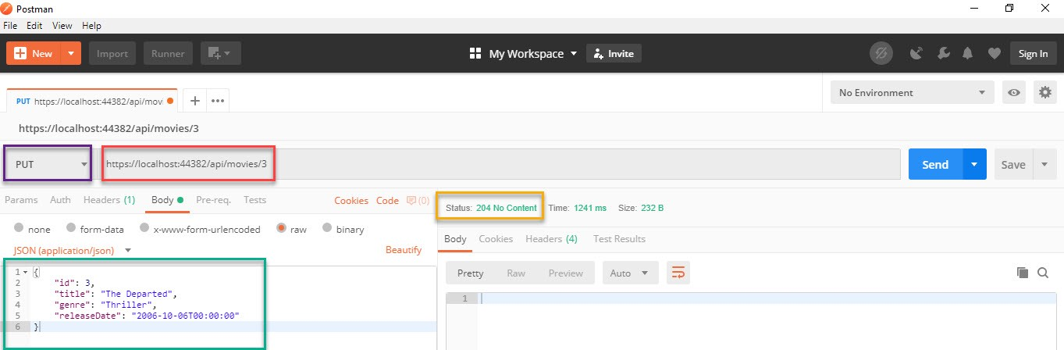**Step 30 :** Click **Send**.

Postman screenshot

**Step 31 :** Again we can see the result from both Postman GET request or the browser:

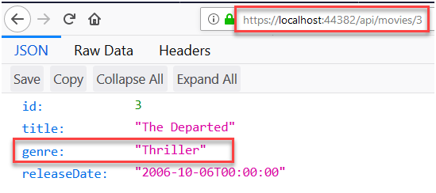

Screenshot of the browser

**Step 32 :** We can check from the **Movie**table in the database too:

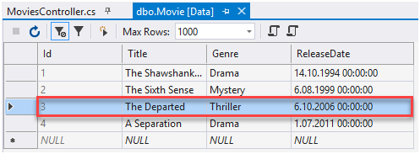

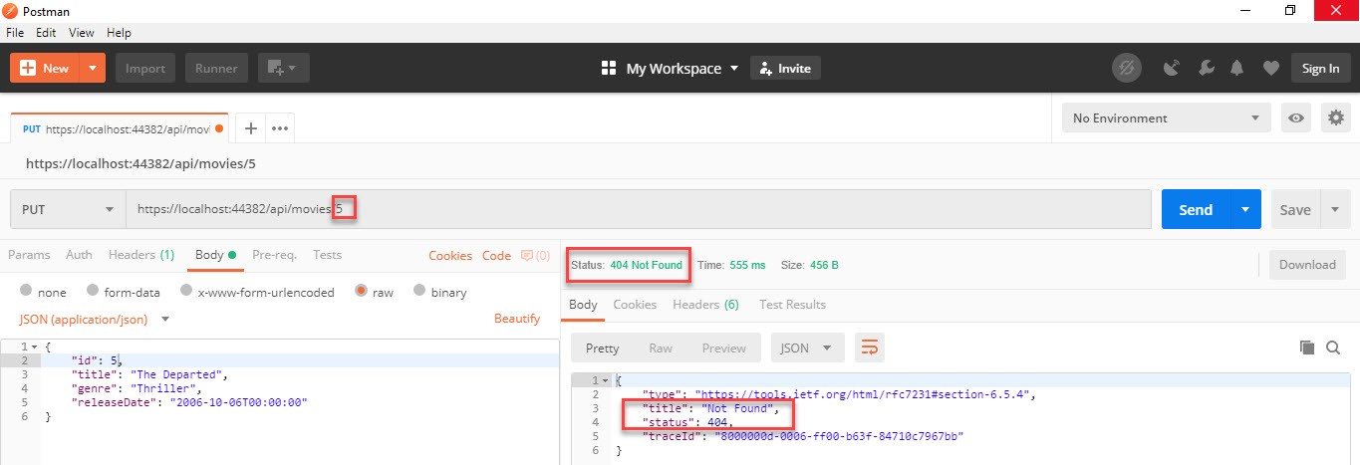If we try to update a record that does not exist in the database we get **404 Not Found** error:

Postman screenshot

**Step 33 : DELETE Method**

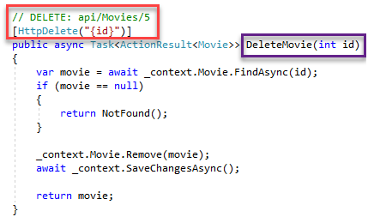

MoviesController.cs

**Step 34 : Testing the DeleteMovie Method**

Let’s test the method using Postman.

Set the method to **DELETE**.

Enter the URI of the object to delete (https://localhost:{port}/api/movies/3)

**Step 35 :** 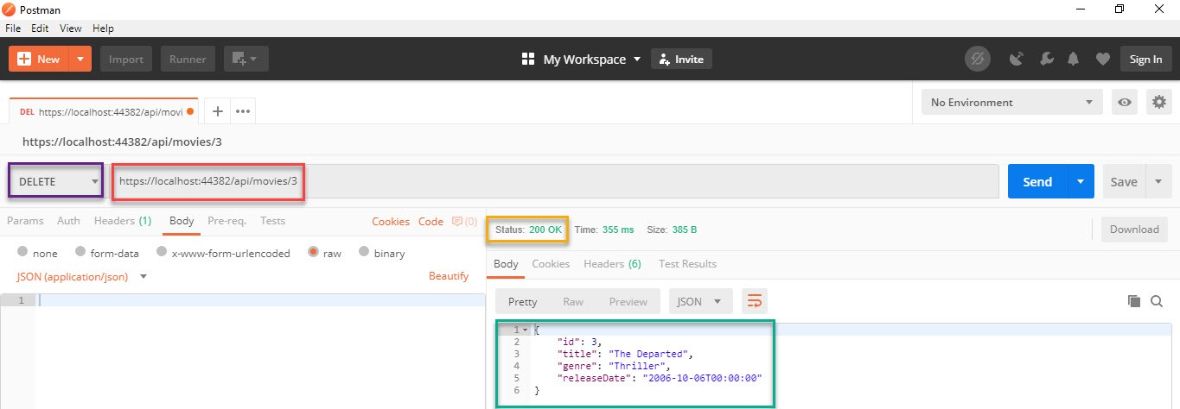Select **Send**

Postman screenshot

**Step 36 :** If we try to get this movie record using the browser we get **404 Not Found** error as expected:

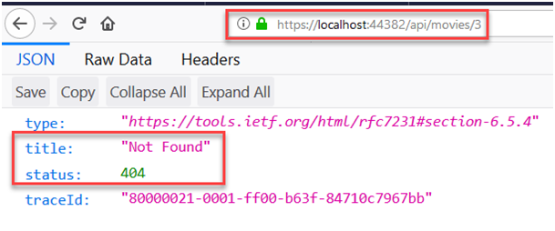

Screenshot of the browser

**Step 37 :** We can check from the database that the record was deleted too:

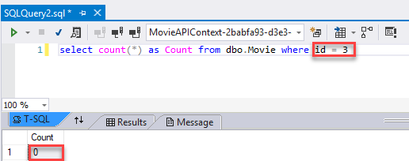

**Practical No : 3**

**Working with Docker , Docker Commands , Docker Image & Containers**

1. Create Docker Hub account (sign up)
2. Login to <https://labs.play-with-docker.com/>

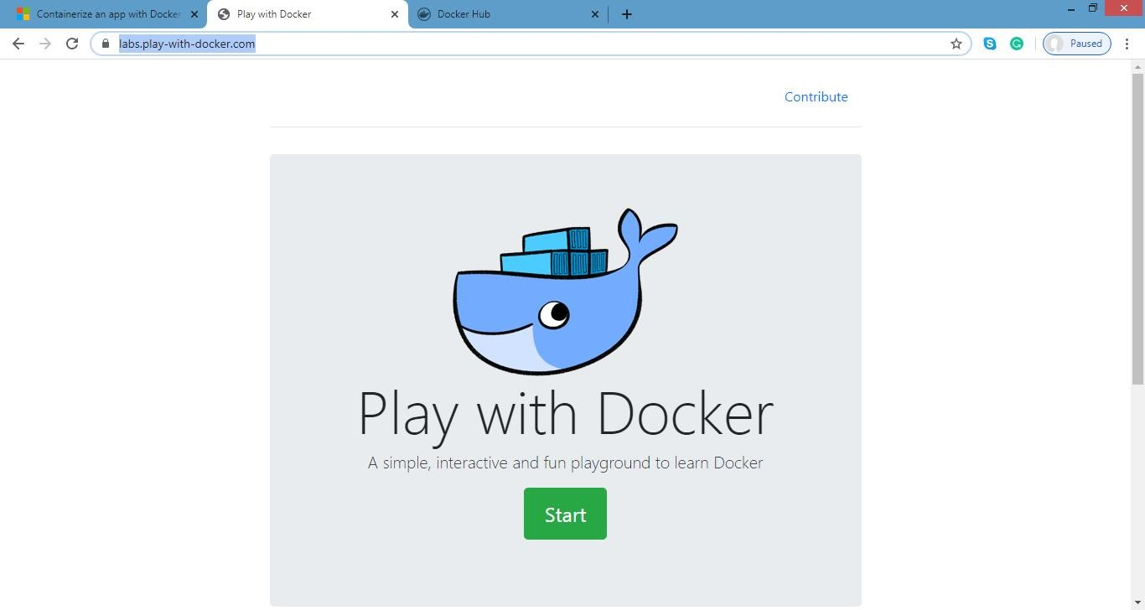

Click on start

3)add new instance

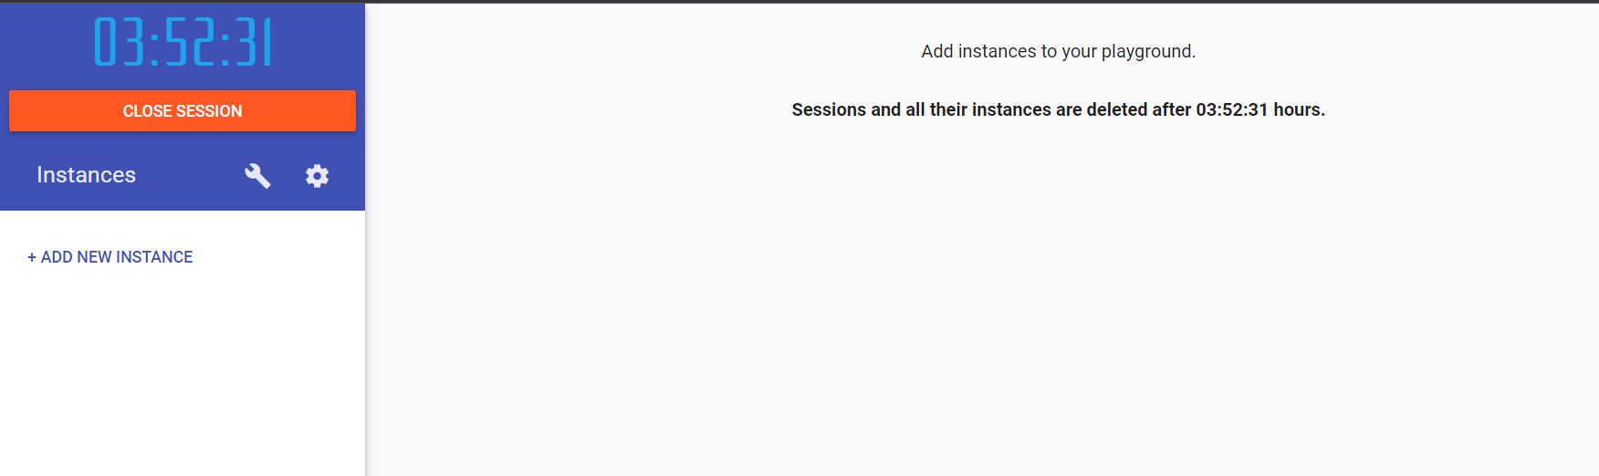

4)perform following:

**Method1:**

**To pull and push images using docker**

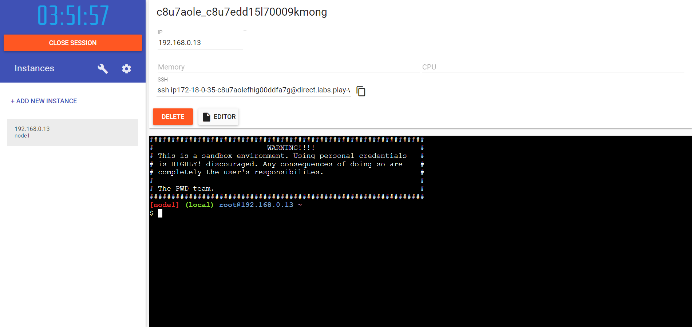

5) To check the docker version

**Command :**

version docker –version

**output:**



6) To pull ready made image

**Command:**

docker pull rocker/verse

**output:**

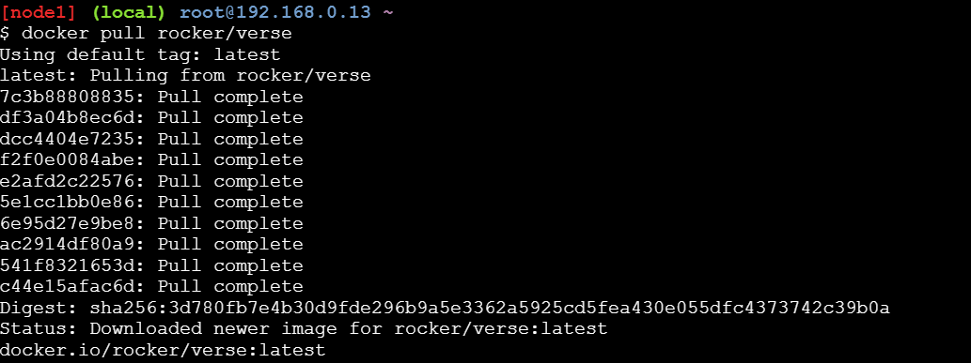

7) To check images in docker

**Command**

docker images

**output:**

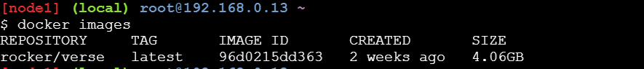

8)Now login to docker hub & create repository

**Output:**

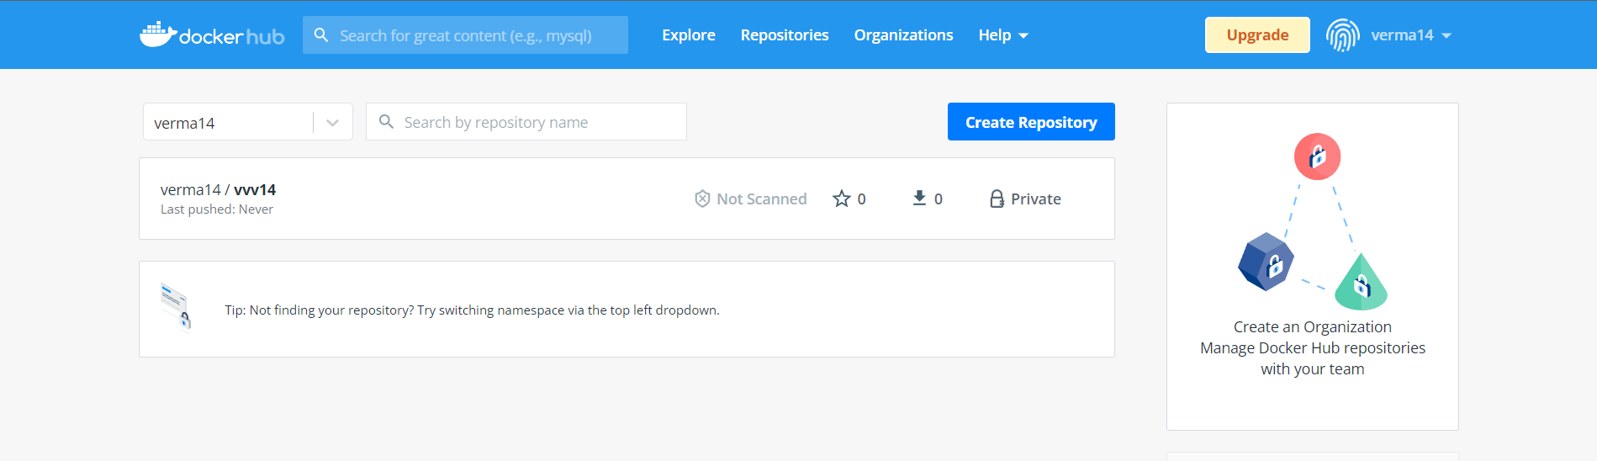

9) Name the repository & Click on Create button

Now check repository created

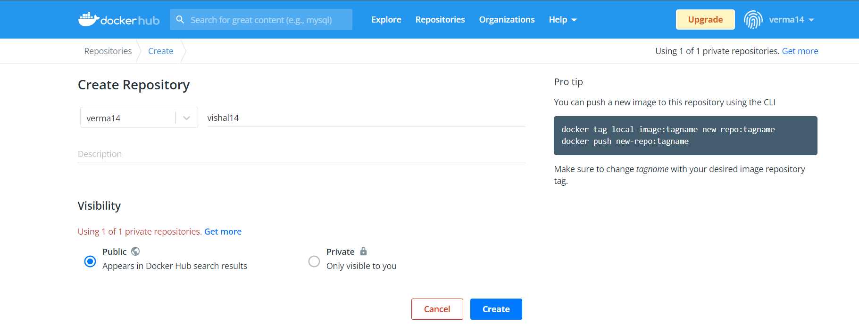

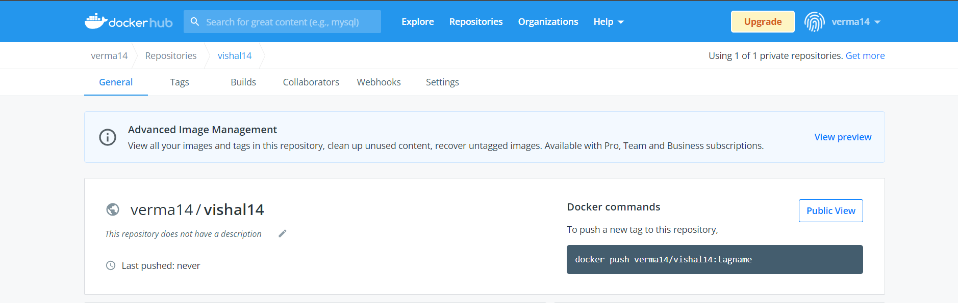

10) To login to your docker account

**Command:**

docker login –username=verma14

password:

note: verma14 is my docker ID . You will use your docker ID here. And enter your password .

**Output:**

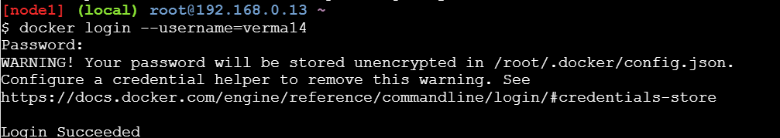

11) To tag image docker tag

**Command:**

docker tag 96d0215dd36 verma14/vishal14:firsttry

note: here 96d0215dd36 this is image id which you can get from docker images command.

**Output:**

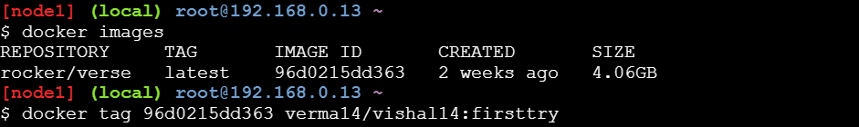

12) To push image to docker hub account

**Command**

docker push verma14/vishal14:firsttry

note: firsttry is tag name created above.

**Output:**

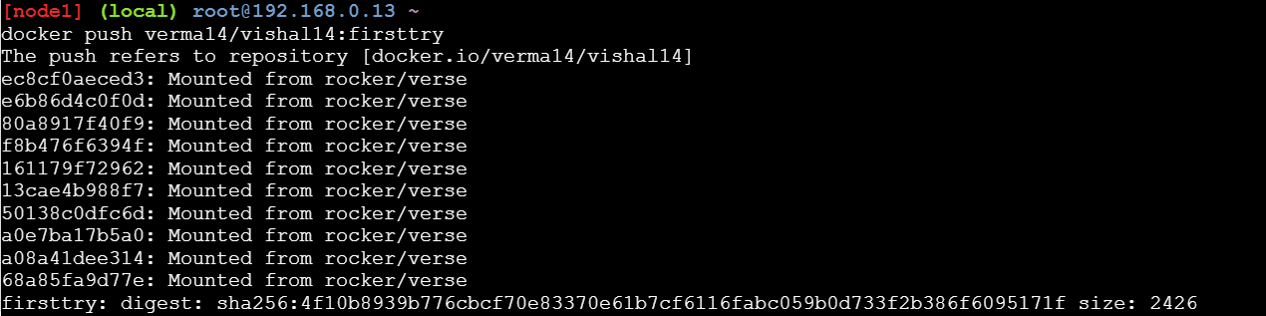

13) Check it in docker hub now

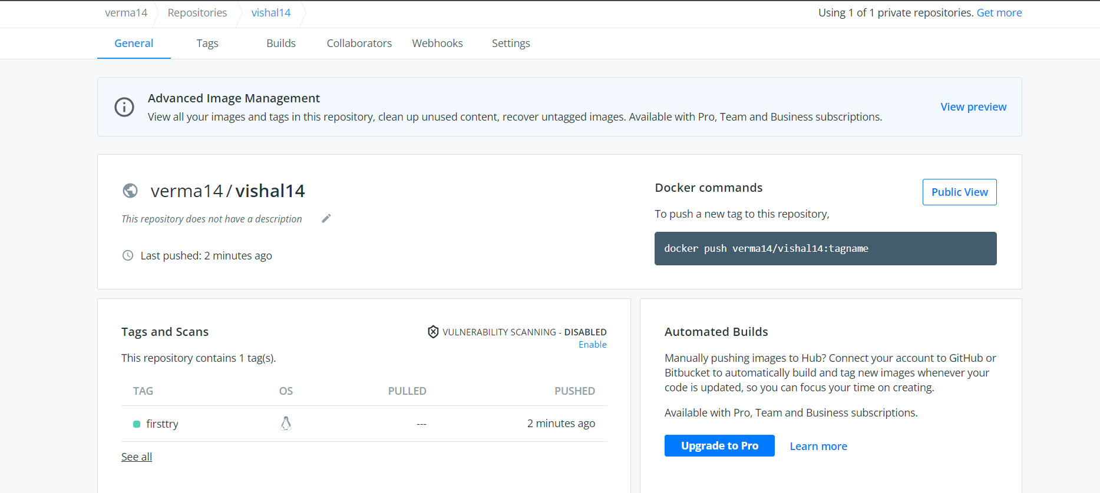

14) Click on tags and check

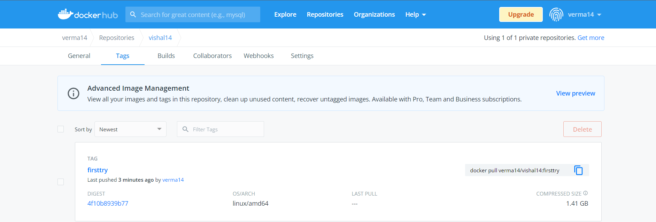

**Method 2: Build an image then push it to docker and run it**

1) To create docker file

**Command :**

cat > Dockerfile <<EOF

FROM busybox

CMD echo "Hello world! This is my first Docker image."

EOF

**Output:**

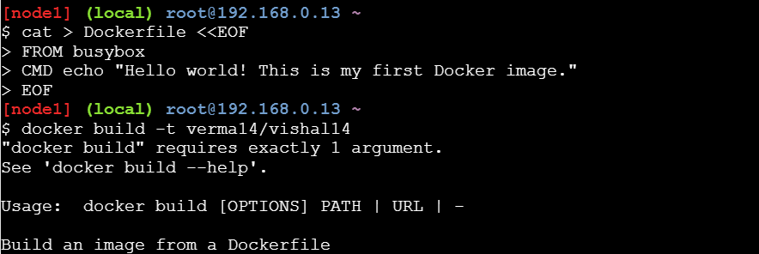

2) To build image from docker file

**Command:**

dokcer build –t verma14/vishal14 .

**Output:**

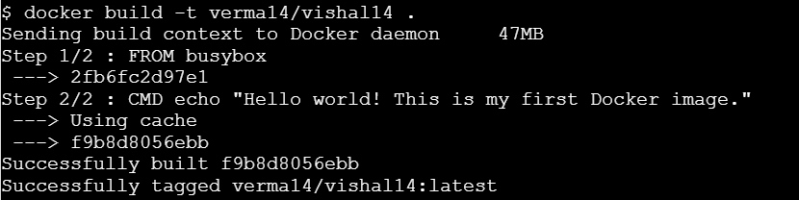

3) to check docker images

**Command**:

docker images

**output:**

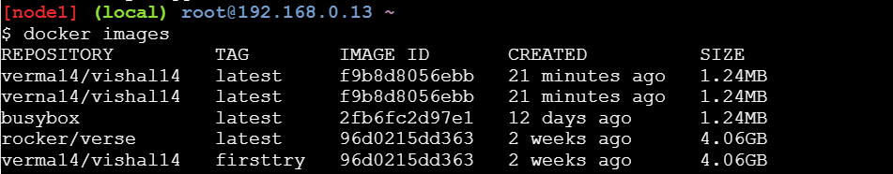

3)To push image to docker hub

**Command:**

docker push verma14/vishal14 .

**Output:**

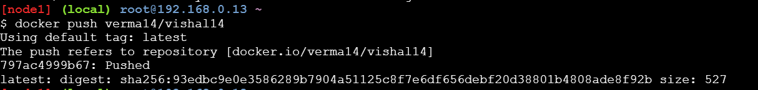

4)Now check it on docker hub

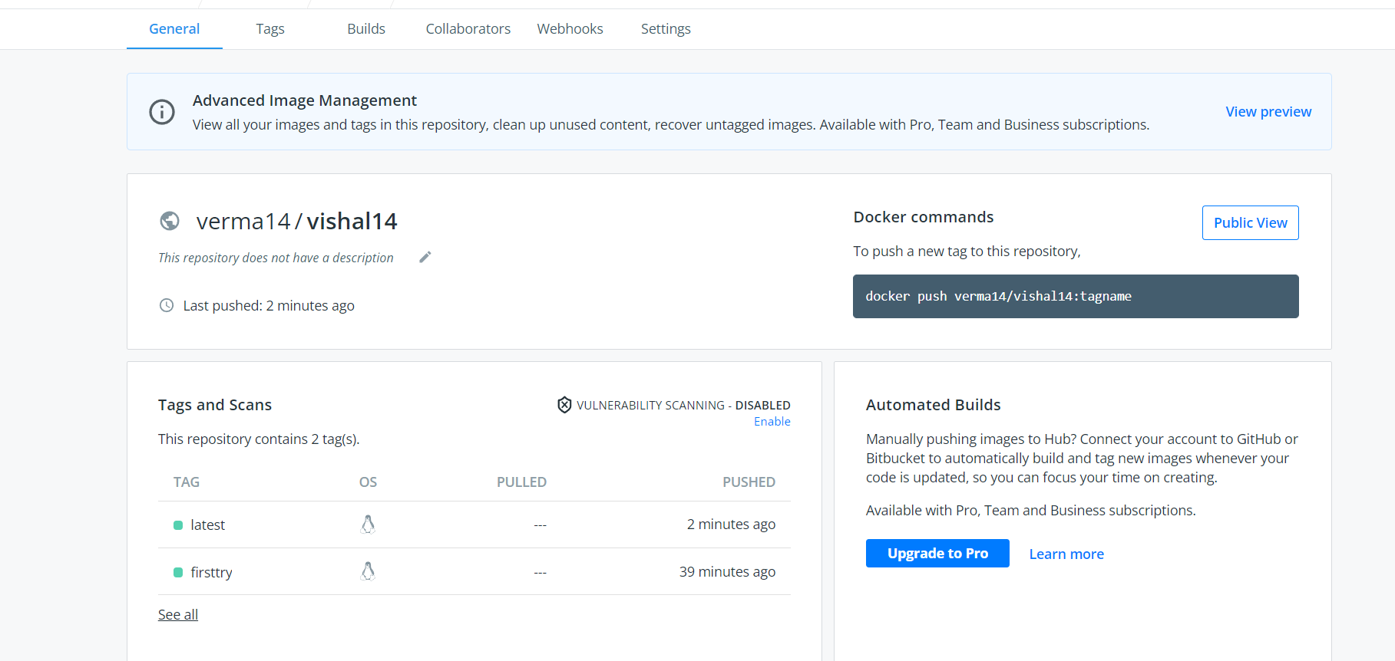

5) To run docker image:

**command**:

docker run verma14/vishal14

**output:**

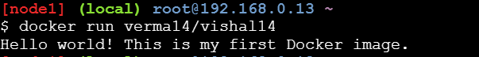

**Practical No : 4**

**Installing software package on Docker , Working with Docker Volumes & Network**

**Perform Following Inside Play-With-Dokcer**

1) Pull nginx image into docker

**Command**:

docker pull nginx

**Output:**

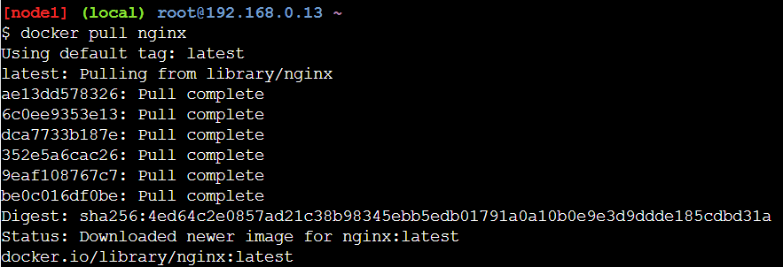

2) Now run the pulled image in Conatiner named “webApp”

**Command:**

docker run -it --name=webApp -d -p 80:80 nginx

**Output:**

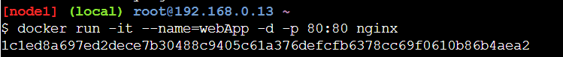

3) Click on port 80 to check output (it shows welcome page)

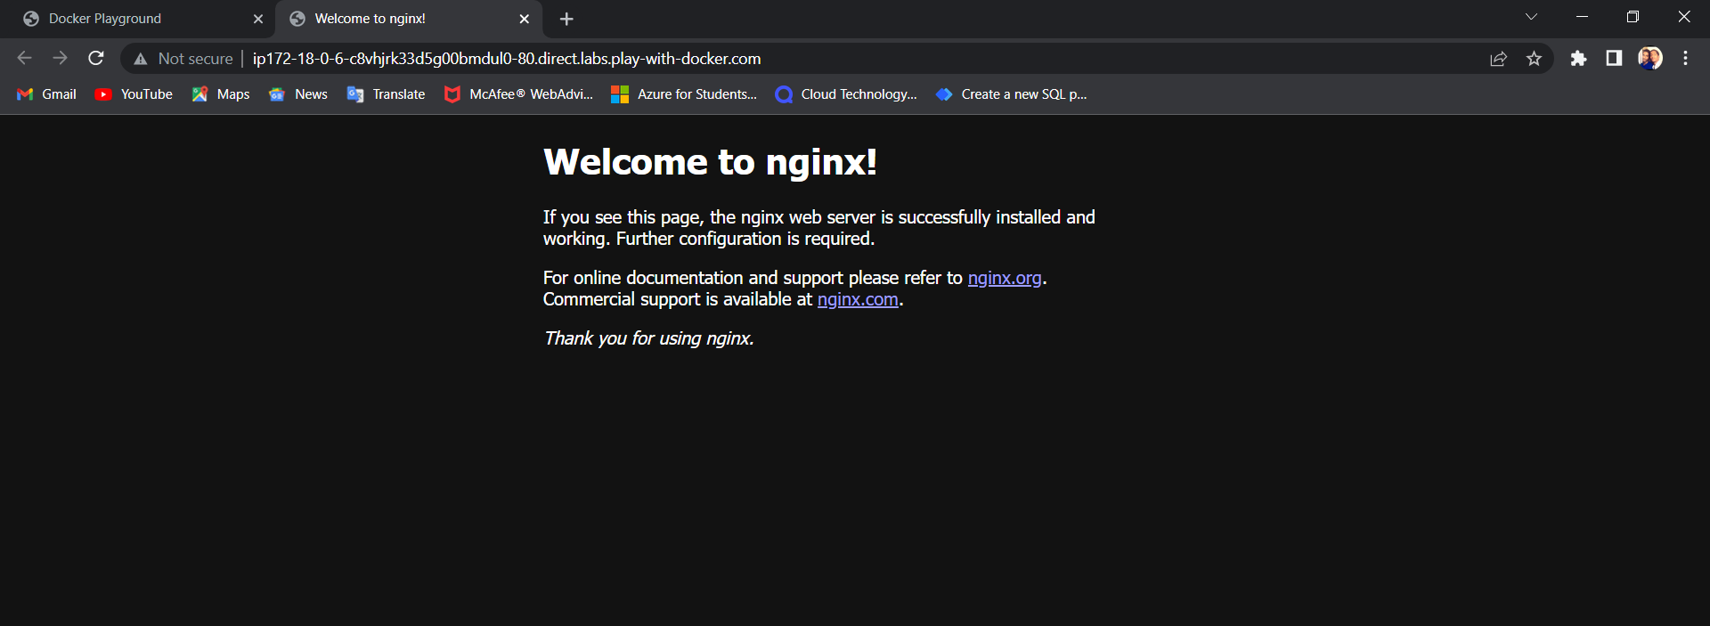

4) We make changes into “index.html” file inside /usr/share/nginx/html folder

**Commands:**

docker exec -it webApp bash //this command to execute bash shell

cd /usr/share/nginx/html // to go inside html folder

echo "Hello KB" > index.html // to change content of index.html file

**output:**

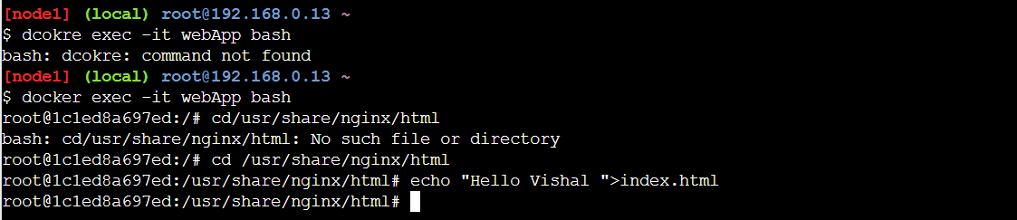

5) Type exit to return to docker prompt and check process status using ps option

**Commands:**

Exit

Docker ps

**Output:**

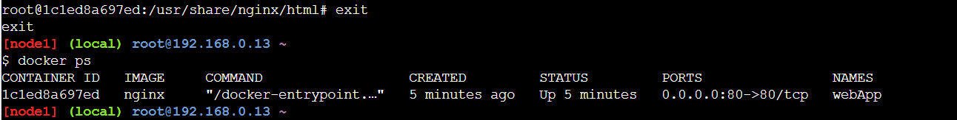

6) Now refresh on port 80 output (you should get modified output)

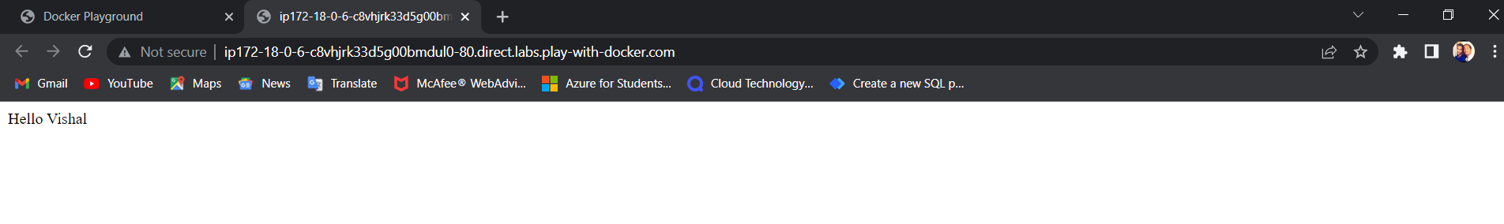

7) Now stop running container named “webApp”.

**Command:**

docker stop webApp

**output:**



8) Start nginx in new container named as “webApp1”.

**Command:**

docker run -it --name=webApp1 -d -p 80:80 nginx

**output:**



9) Now Click on port 80 (you will see the welcome page again)

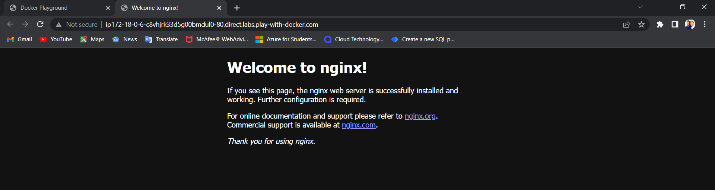

10) To solve this issue we create new volume.

**Command:**

docker volume create MyVolume

**output:**



11) Check volume is created

**Command:**

docker volume ls

**output:**



12) Check details of volume

**Command:**

docker volume inspect MyVolume

**output:**

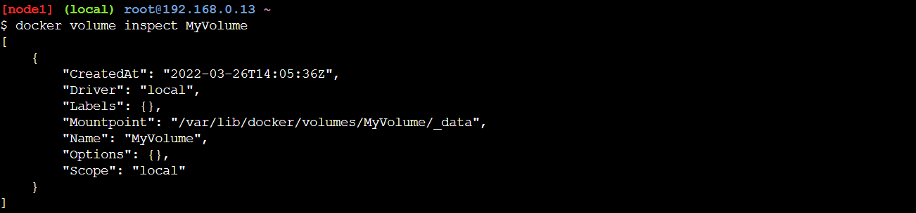

**\*IMP Step-**

**Command:** docker stop webApp1

**Output:**



13) Mount this volume to nginx new container named “webApp2”

**Command:**

docker run -d --name=webApp5 --mount source=MyVolume,destination=/usr/share/nginx/html -p 80:80 nginx

**Output:**



14) Now keep on doing “ls” and “cd “ to go inside \_data folder of our volume “MyVolume”

**Commands:**

ls /

cd /var/lib/docker

ls

**output:**

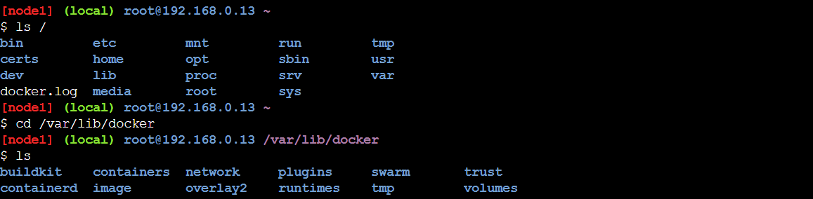

**Commands:**

cd volumes

ls

cd MyVolume

ls

**output:**

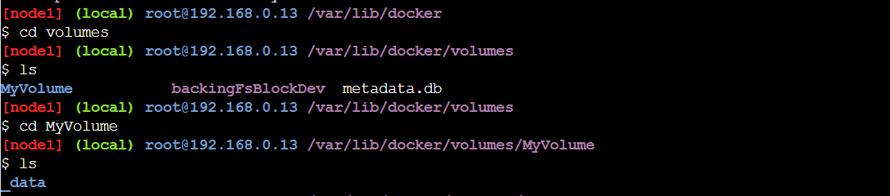

**Commands:**

cd \_data

ls

**output:**

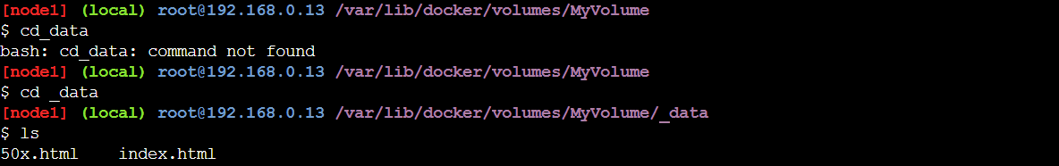

15) Modify contents of index.html file with “from MyVolume Hello VISHAL”

Command:

echo “from MyVolume Hello VISHAL” > index.html

(note: don’t paste this type this)

**Output:**



16) Now refersh port 80 (to get modified output)

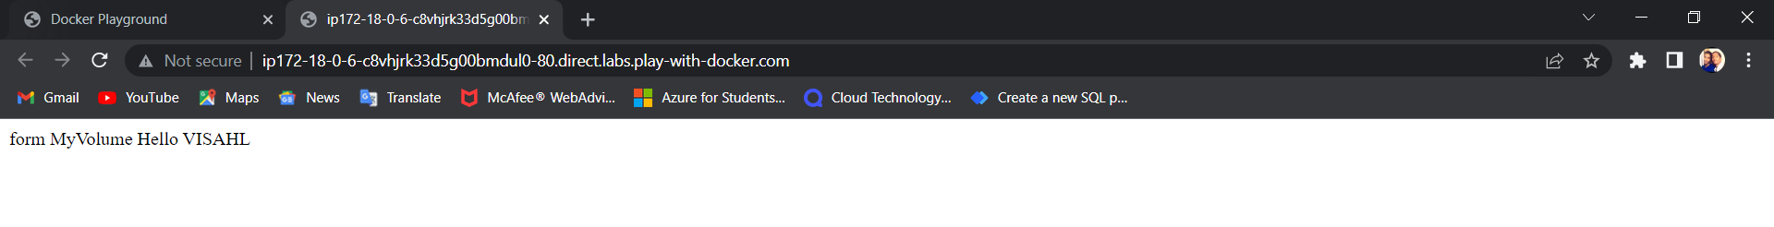

17) Now stop this running container named “webApp2”

**Command:**

docker stop webApp2

**output:**



18) Now run nginx in new container named “webApp3”

**Command:**

docker run -d --name=webApp3 --mount source=MyVolume,destination=/usr/share/nginx/html -p 80:80 nginx

**output:**



19) Click on port 80 and refresh the page you should get edited file as output.

We can load the page again localhost:80 and still see the html file that we edited in the volume. So, with the help of volumes, we can easily access the data even we stop the container and it’s very easy to access

data and import the data to anywhere.

**Output:**

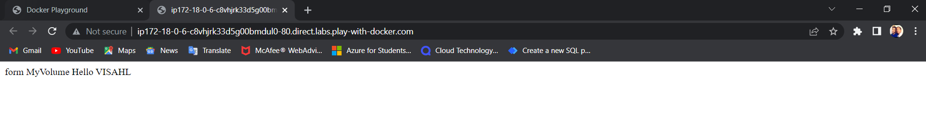

**Practical No: 05**

**Working with Docker Swarm**

**Describe app using stack file :**

**Let write the simple stack file to run and manage our bulletin board . Place the following code in the file call bb-stack.yaml and save it .**

**version: "3.7"**

**services:**

**bb-app:**

**image: getting-started:latest**

**ports:**

**- "3000:3000"**

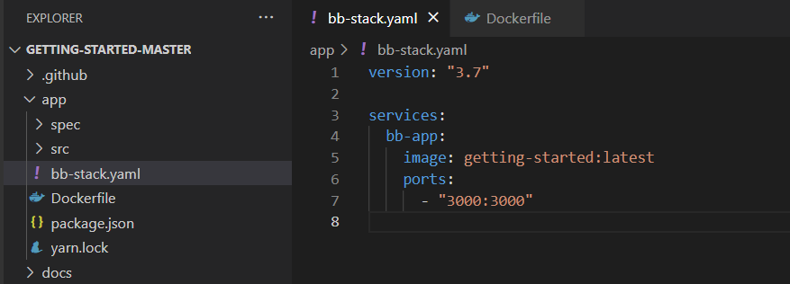

Deploy and check your application .

1.Deploy your application to Swarm:

**Docker run -dp 3000:3000 getting-started:latest**



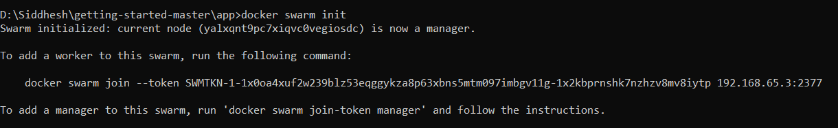

**docker stack deploy -c bb-stack.yaml demo**

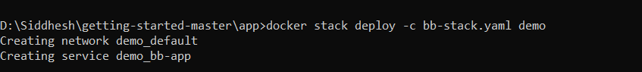

2. Make sure everything worked by listing your service

**docker service ls**

If all has gone well, your service will report with 1/1 of its replicas created



This indicates 1/1 containers you asked for as part of your services are up and running. Also, we see that port 8000 on your development machine is getting forwarded to port 8080 in your bulletin board container.

3. Open a browser and visit your bulletin board at localhost:8000; you should see your bulletin board, the same as when we ran it as a stand-alone container in Docker images and container section of this file.

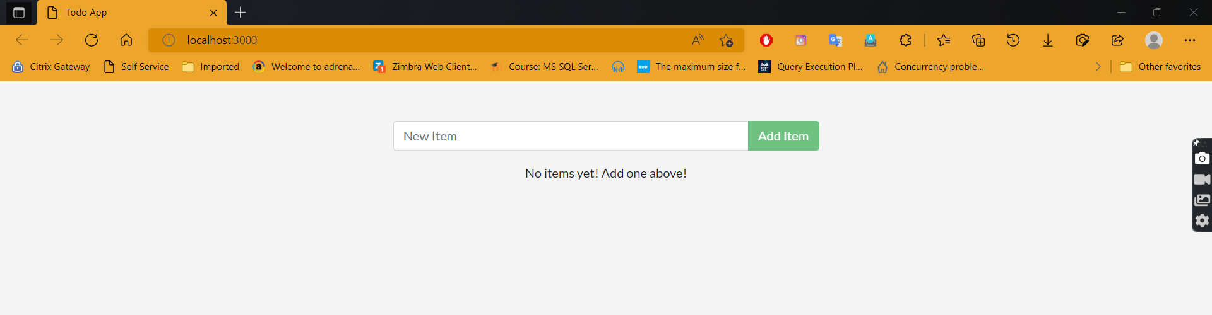

4. Once satisfied, tear down your application

**docker stack rm demo**

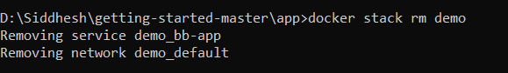

**Practical No: 06**

**Working with Circle CI for continuous integration.**

**Step 1 - Create a repository**

1. Log in to GitHub and begin the process to create a new repository.

2. Enter a name for your repository (for example, hello-world).

3. Select the option to initialize the repository with a README file.

4. Finally, click Create repository.

5. There is no need to add any source code for now.

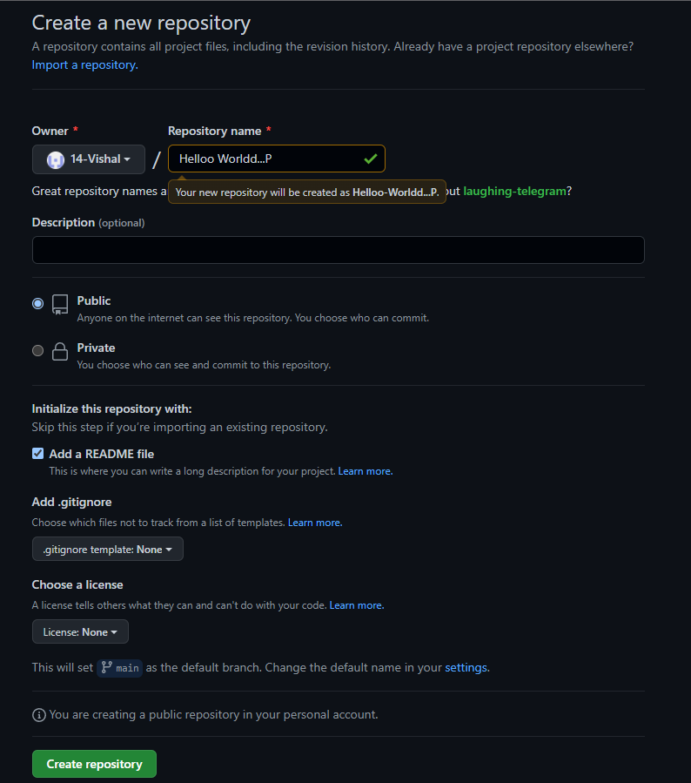

Login to Circle CI **https://app.circleci.com/ Using GitHub Login, Once logged in navigate to Projects.**

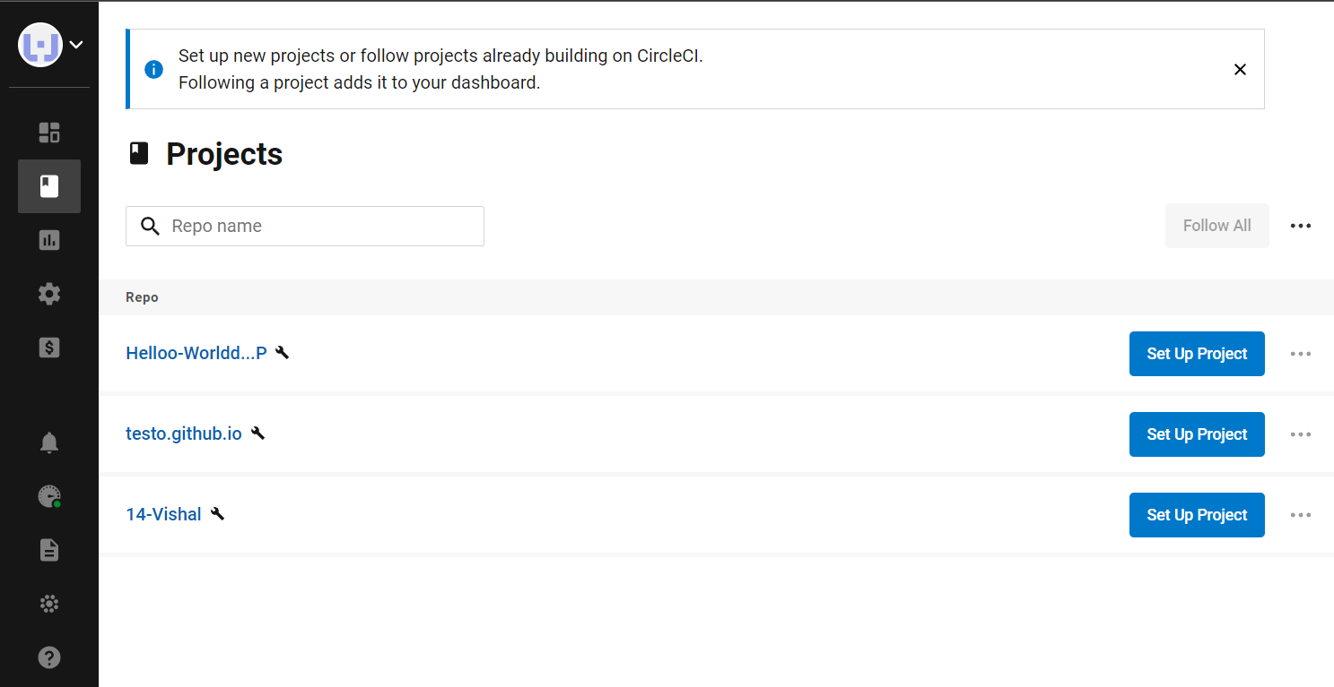

**Step 2 - Set up CircleCI**

1. Navigate to the CircleCI Projects page. If you created your new repository under an organization, you will need to select the organization name.

2. You will be taken to the Projects dashboard. On the dashboard, select the project you want to set up (hello-world).

3. Select the option to commit a starter CI pipeline to a new branch, and click Set Up Project. This will create a file .circleci/config.yml at the root of your repository on a new branch called circleci-project-setup.

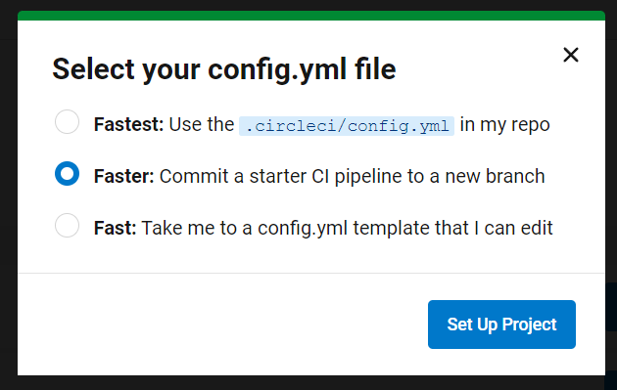

**Step 3 - Your first pipeline**

On your project’s pipeline page, click the green Success button, which brings you to the workflow that ran (say-hello-workflow).

Within this workflow, the pipeline ran one job, called say-hello. Click say-hello to see the steps in this job:

a. Spin up environment

b. Preparing environment variables

c. Checkout code

d. Say hello

**Now select the “say-hello-workflow” to the right of Success status column**

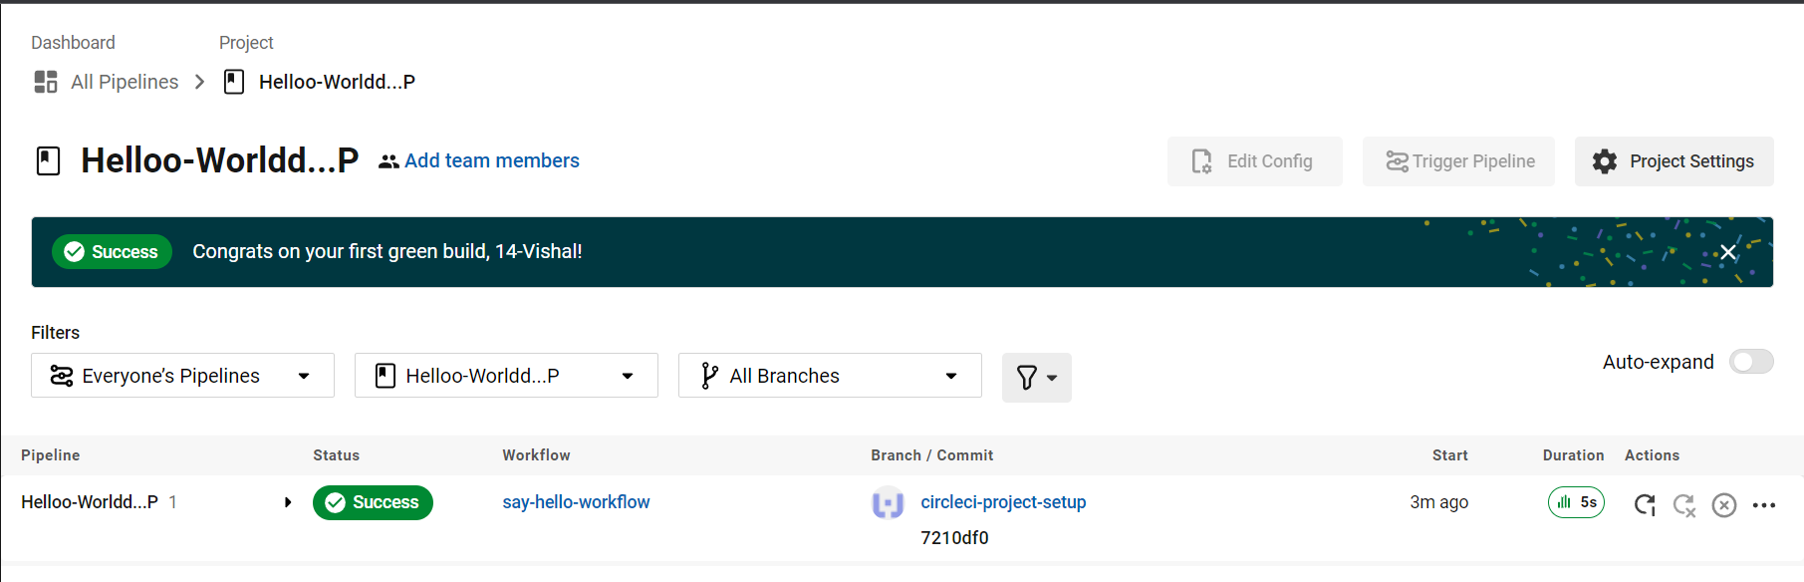

**Select “say-hello” Job with a green tick**

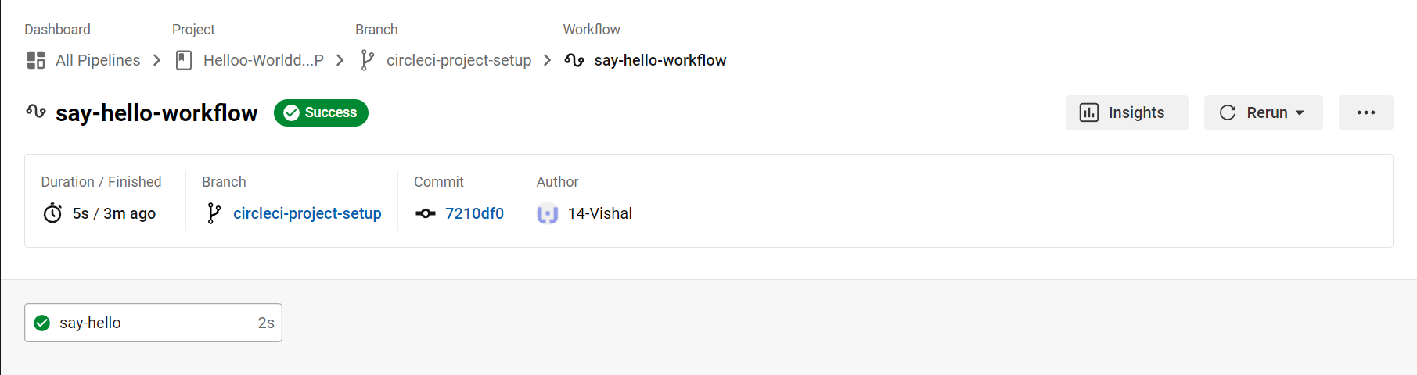

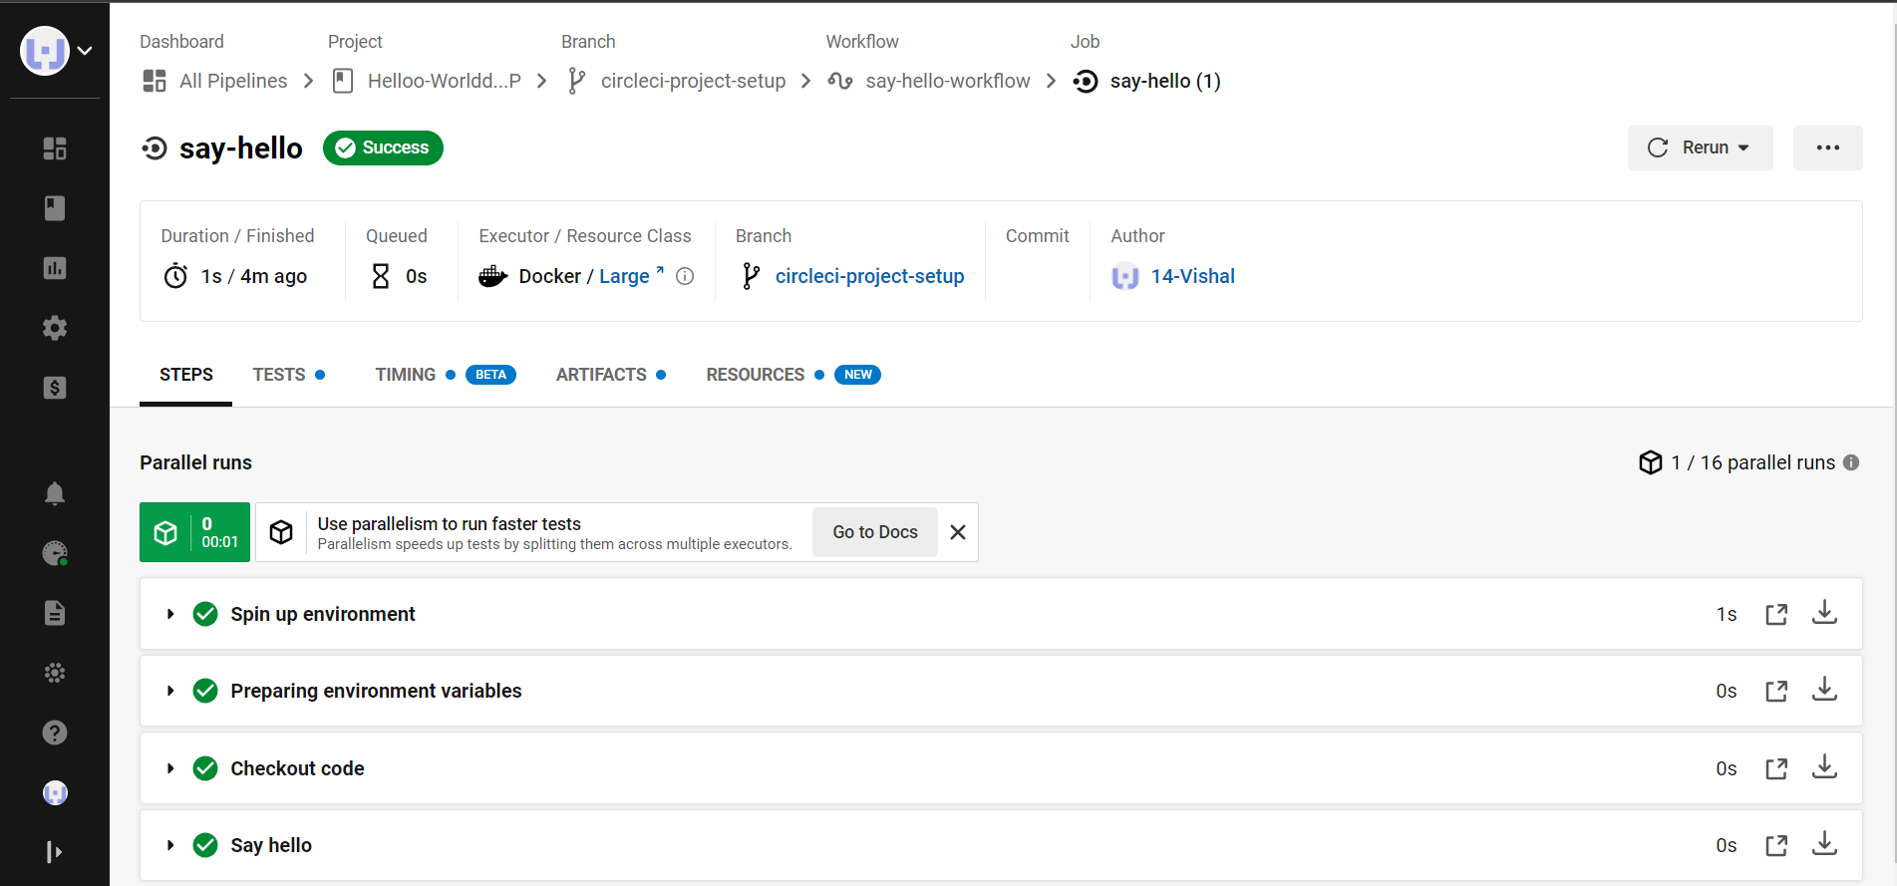

**Select Branch and option circleci-project-setup**

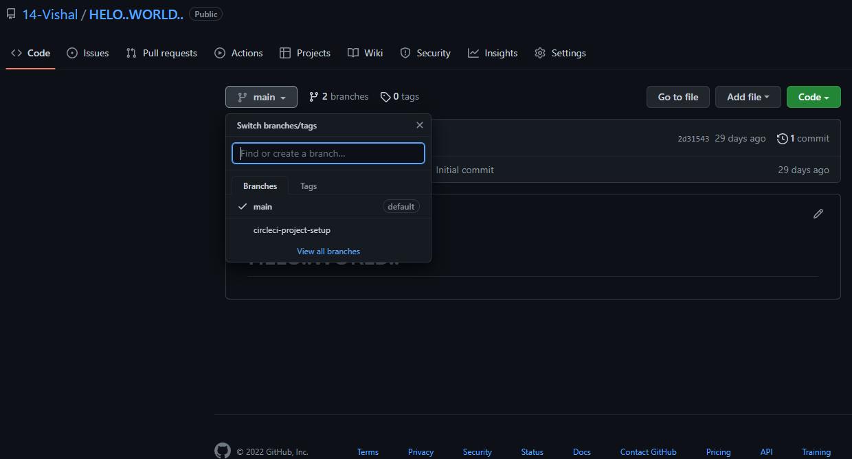

**Step 4 - Break your build**

**In this section, you will edit the .circleci/config.yml file and see what happens if a build does not complete successfully.**

**It is possible to edit files directly on GitHub.**

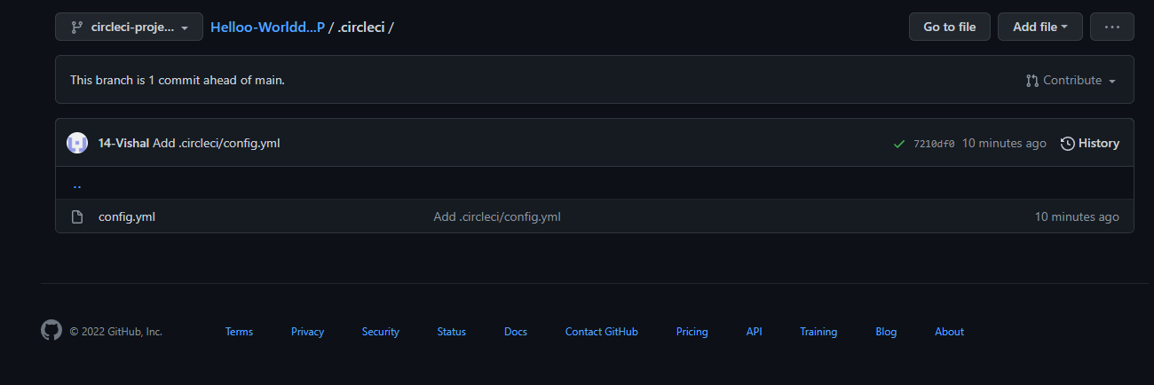

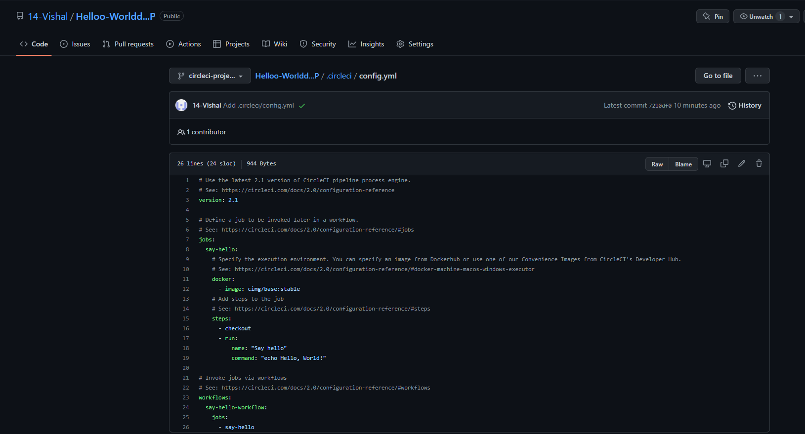

**Replace the above code with this code**

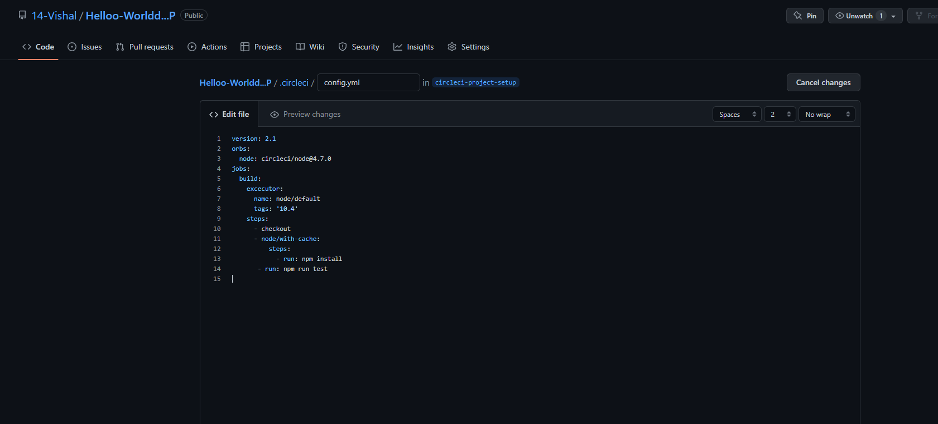

**Scroll down and Commit your changes on GitHub**

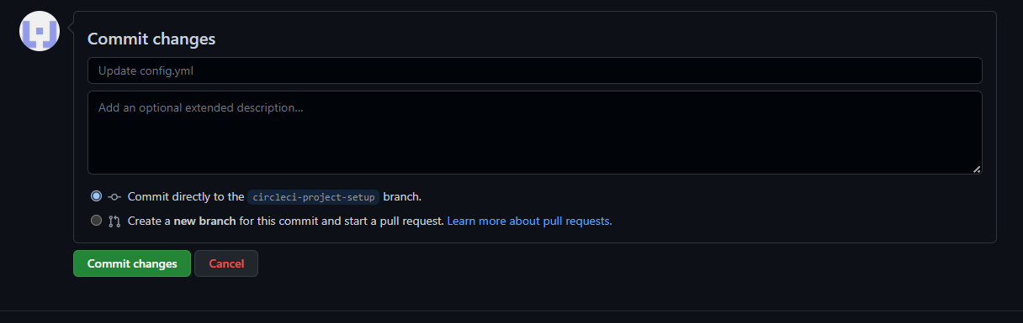

**After committing your changes, then return to the Projects page in CircleCI. You should see a new pipeline running… and it will fail! What’s going on? The Node orb runs some common Node tasks. Because you are working with an empty repository, running npm run test, a Node script, causes the configuration to fail. To fix this, you need to set up a Node project in your repository.**

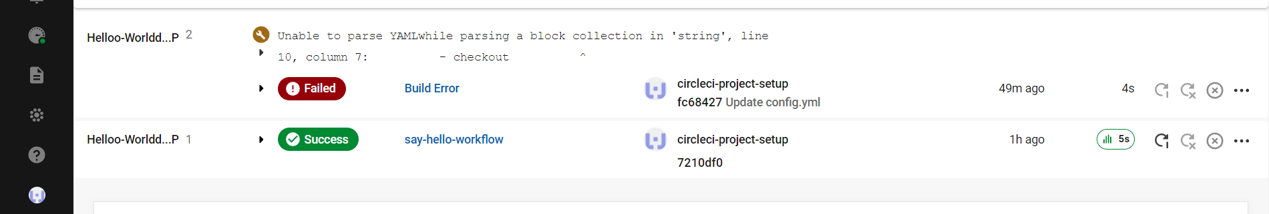

**Step 5 – Use Workflows You do not have to use orbs to use CircleCI. The following example details how to create a custom configuration that also uses the workflow feature** of CircleCI.

1) Take a moment and read the comments in the code block below. Then, to see workflows in action, edit your **.circleci/config.yml file** and copy and paste the following text into it.

2) Commit these changes to your repository and navigate back to the CircleCI Pipelines page. You should see your pipeline running.

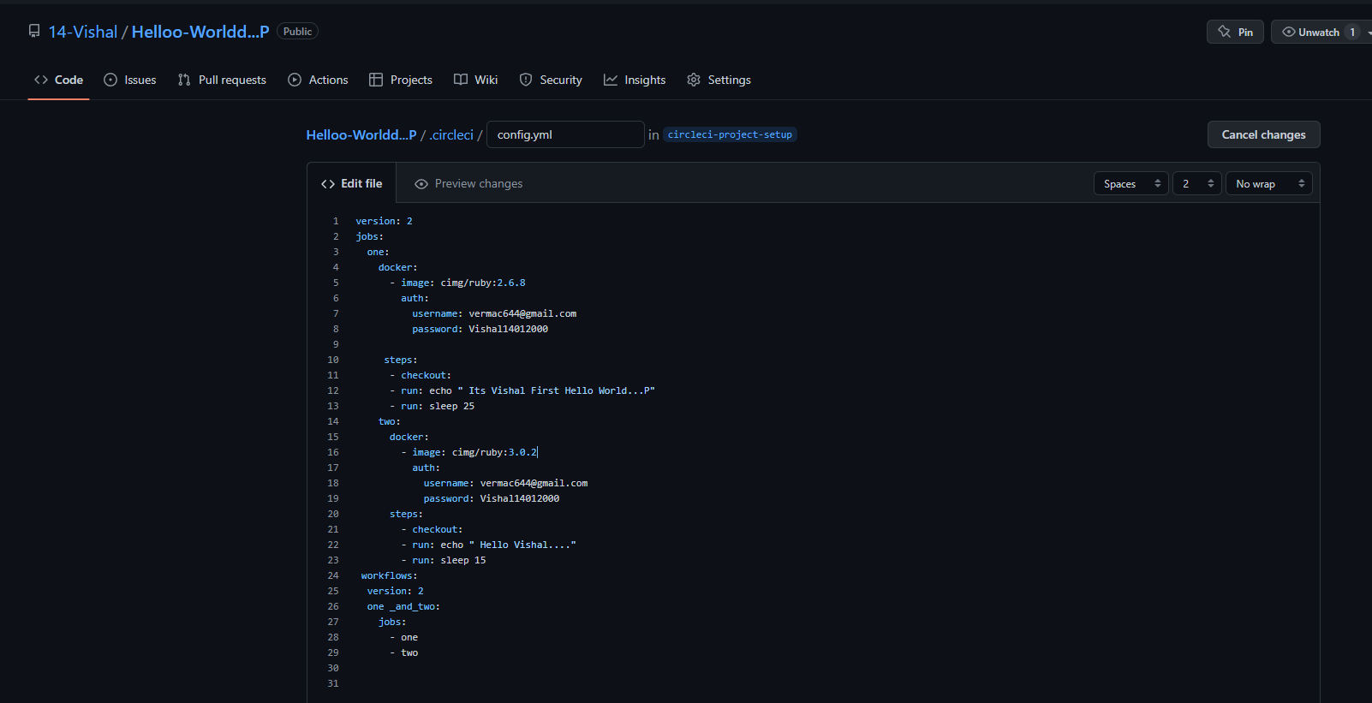

3) Click on the running pipeline to view the workflow you have created. You should see that two jobs ran (or are currently running!) concurrently.

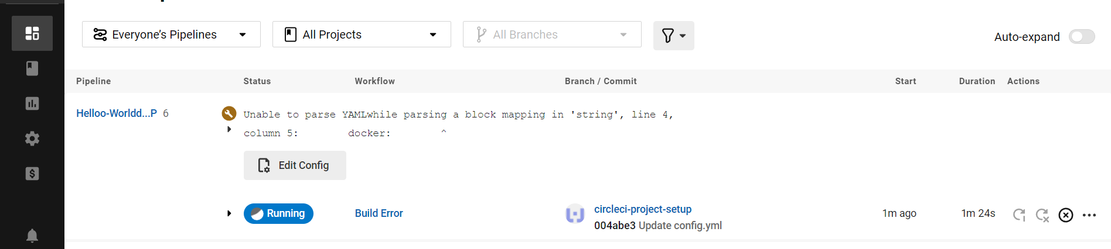

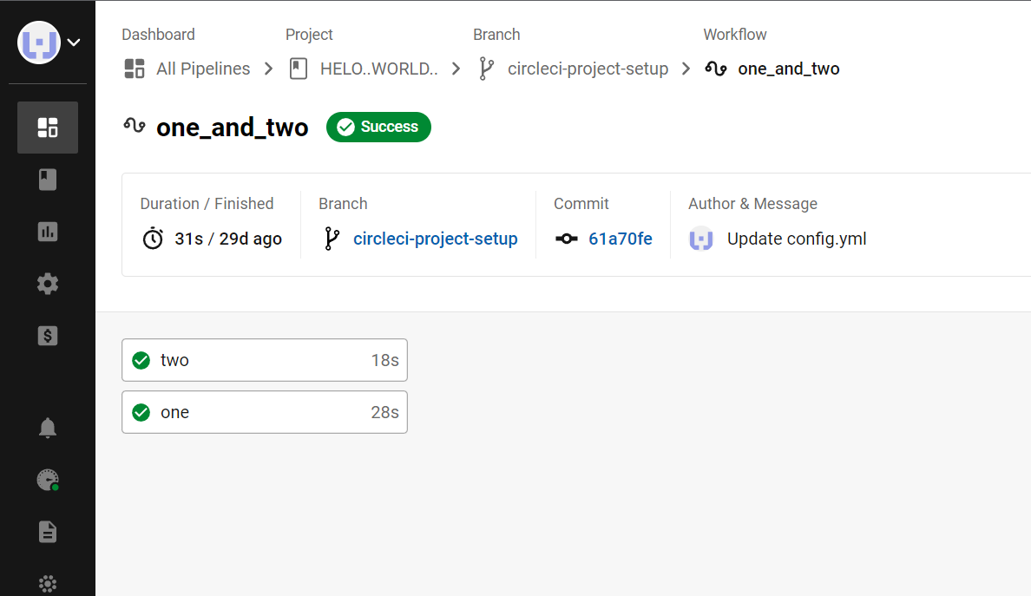

**Step 5 – Add some changes to use workspaces**

**Each workflow has an associated workspace which can be used to transfer files to downstream jobs as the workflow progresses. You can use workspaces to pass along data that is unique to this run and which is needed for downstream jobs. Try updating config.yml to the following:**

**Updated config.yml in GitHub file editor should be updated like this**

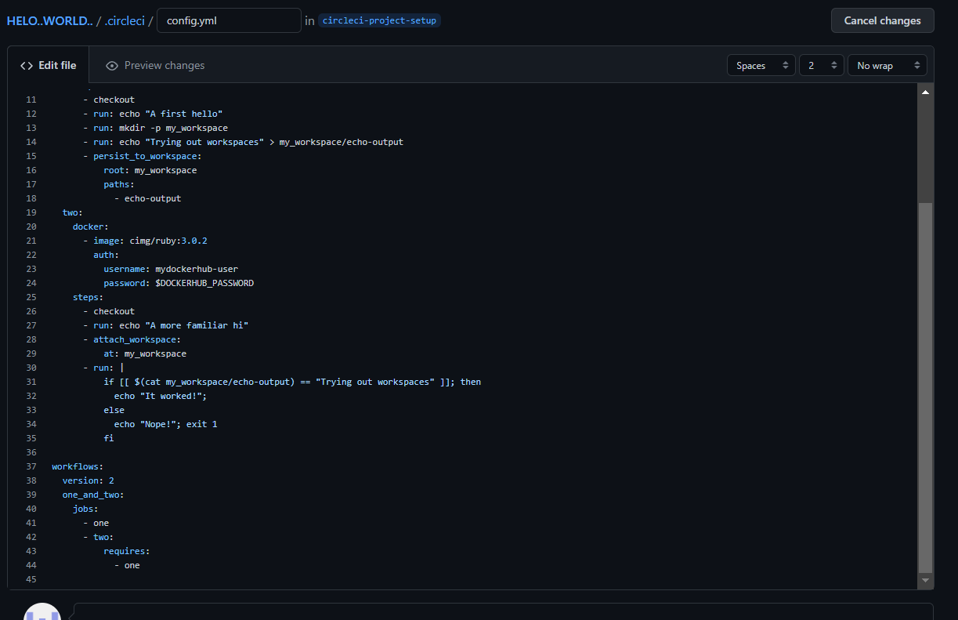

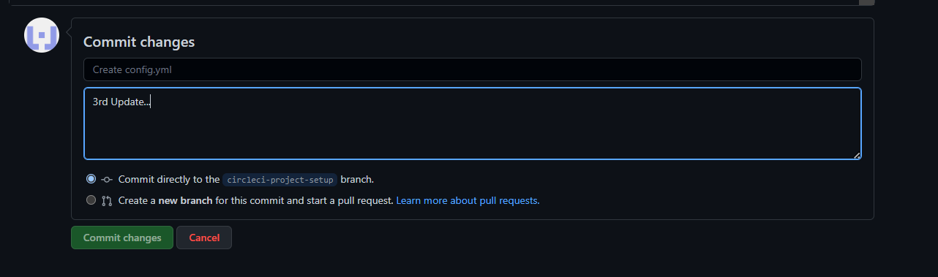

**Finally your workflow with the jobs running should look like this**

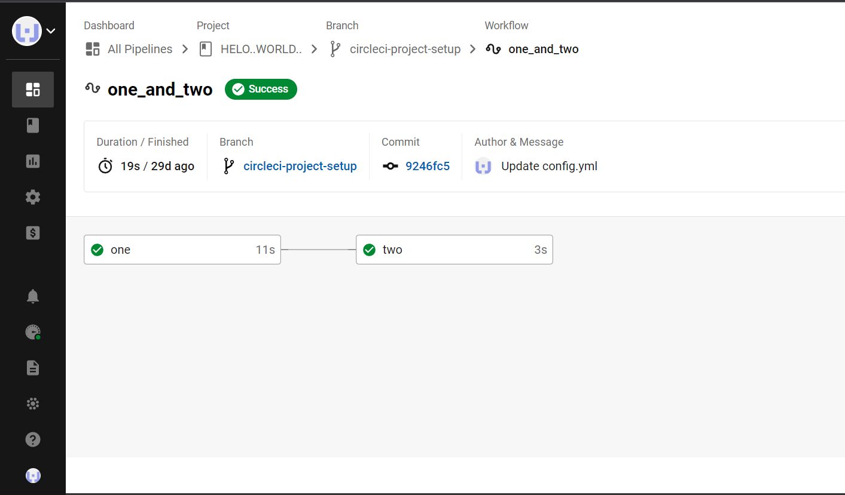

**Practical No : 7**

**Creating Microservice with ASP.NET Core**

Now, we are going to create the ASP.NET Core Web API project using Visual Studio 2019.

1. Open Visual Studio 2019 and then click on the Create a new project option as shown in the below image.

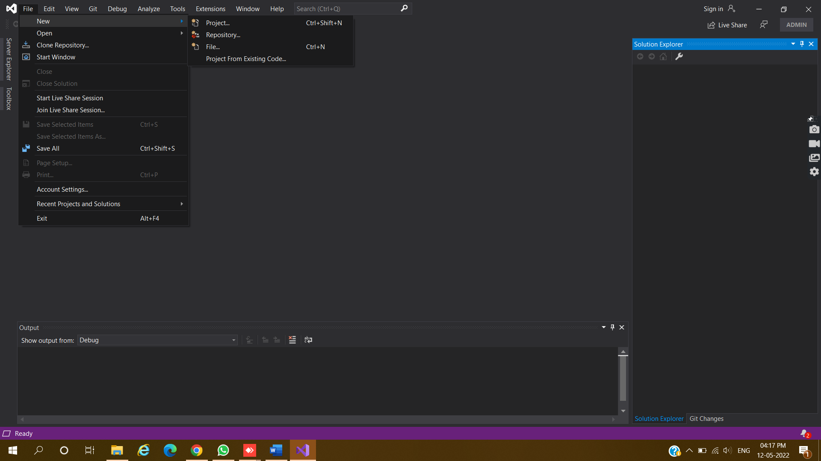

1. Select ASP.NET Core Web API as a Project Template.

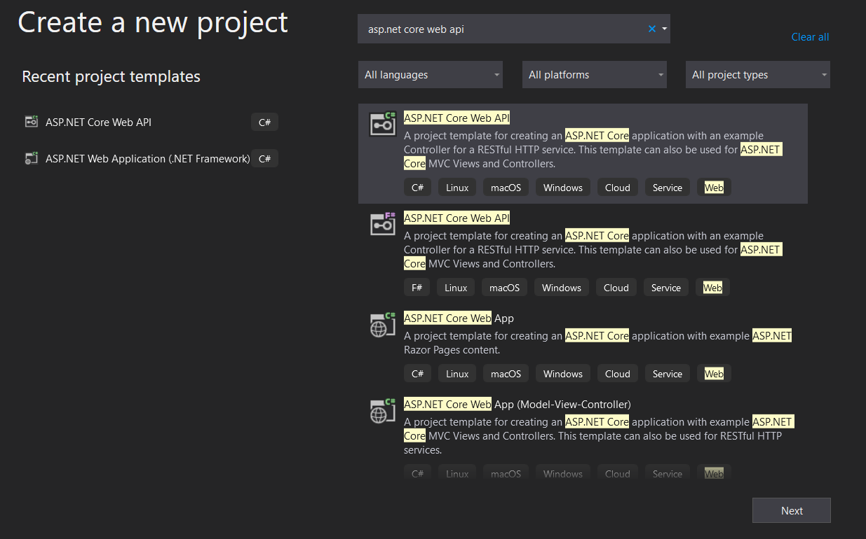

1. Give name to your Project as SchoolAdmissionManagementand to Solution as SchoolManagementSystem .

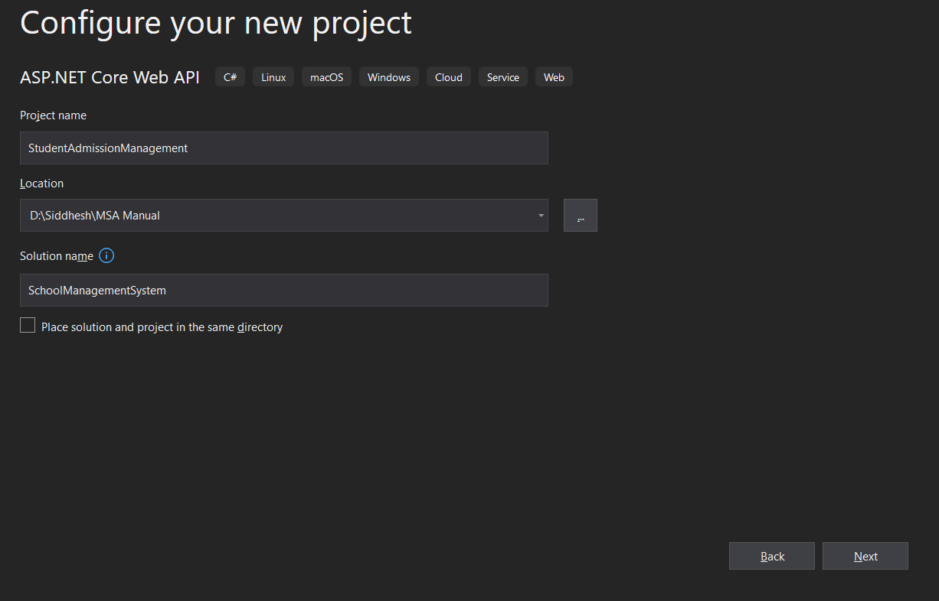

1. Select .NET Core 3.1 Framework and Click Create.

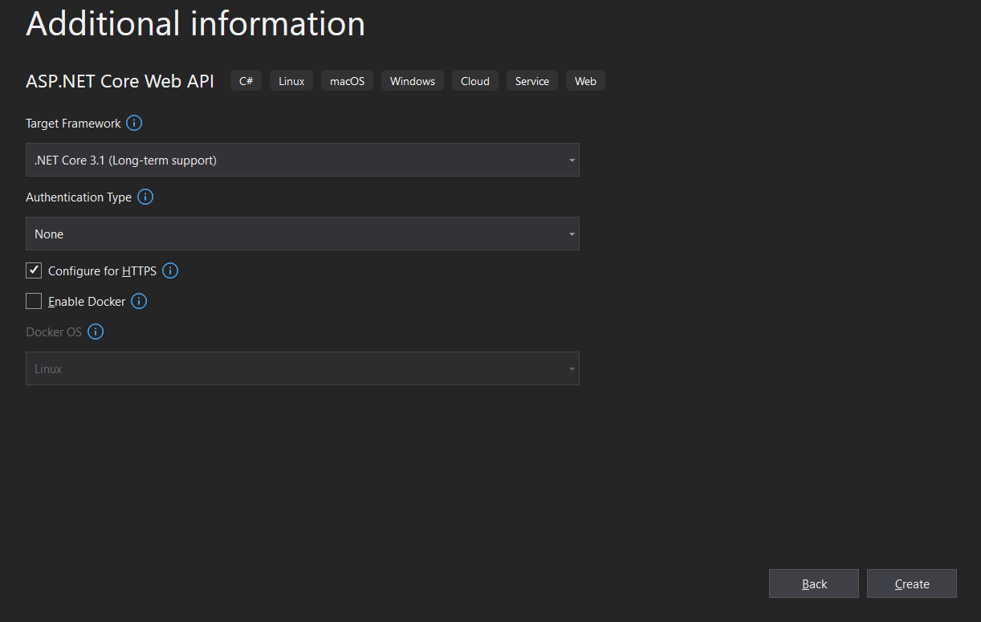

1. Once you click on the Create button, it will create the ASP.NET Core Web API project with the following file and folder structure.

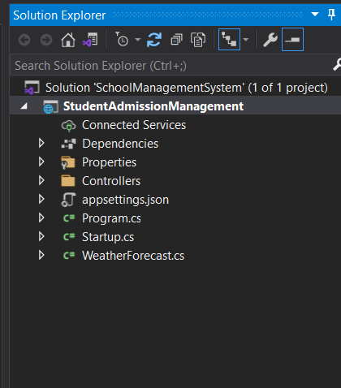

1. Let us create one more project under the solution which is another microservice for purpose of student attendance. To do so, right-click on the solution and then select Add => New Project option from the context menu as shown in the below image.

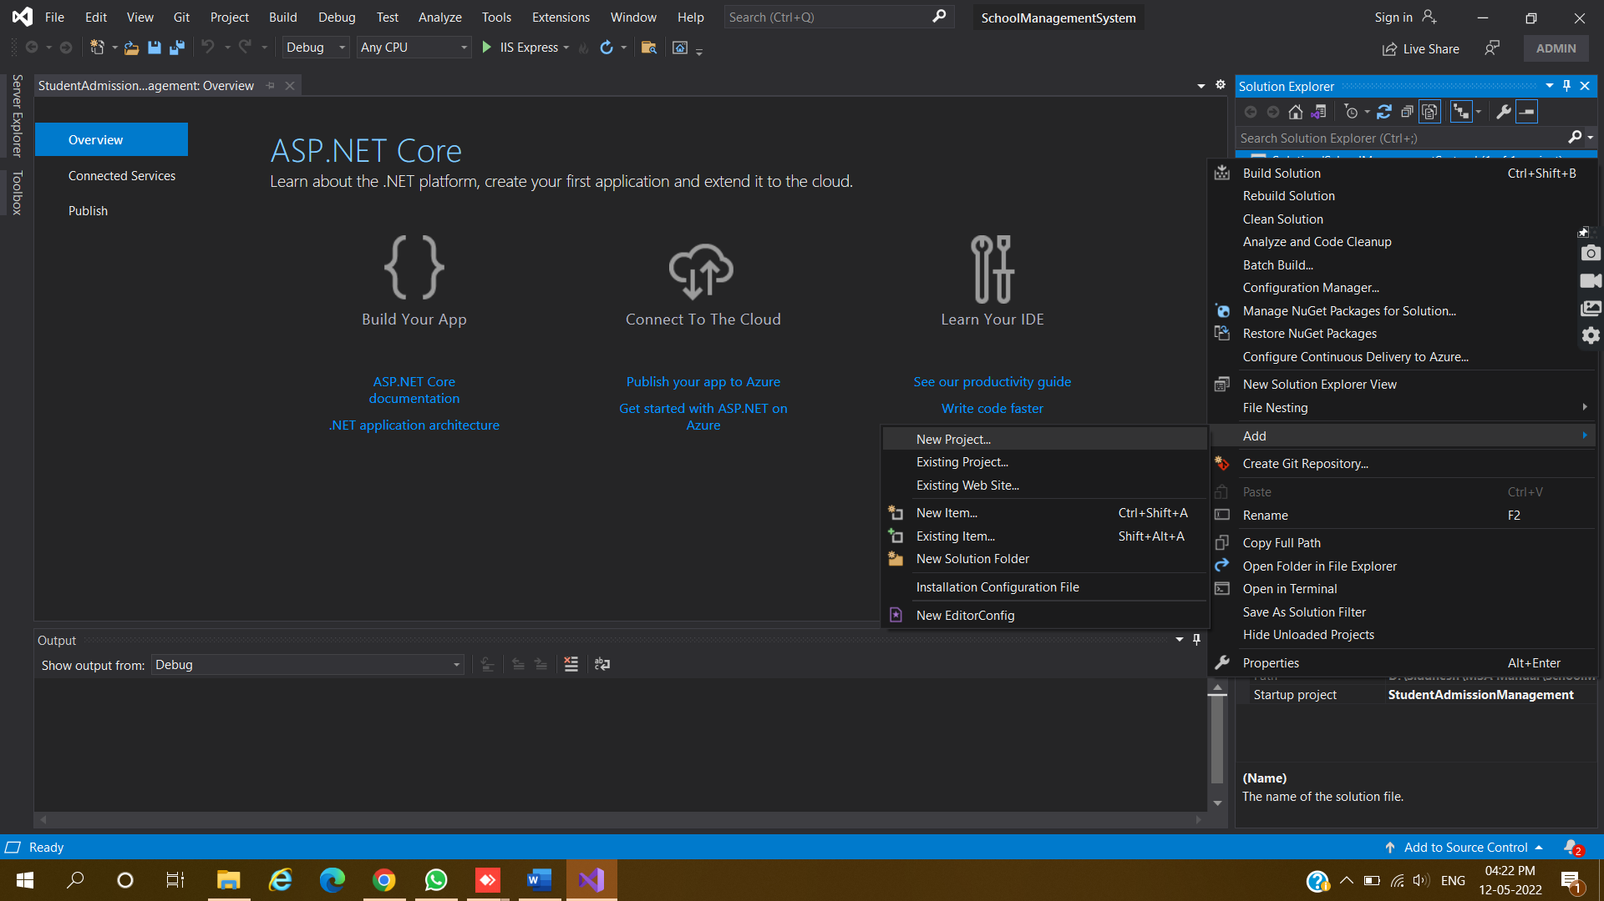

1. Select ASP.NET Core Web API and click on the Next button

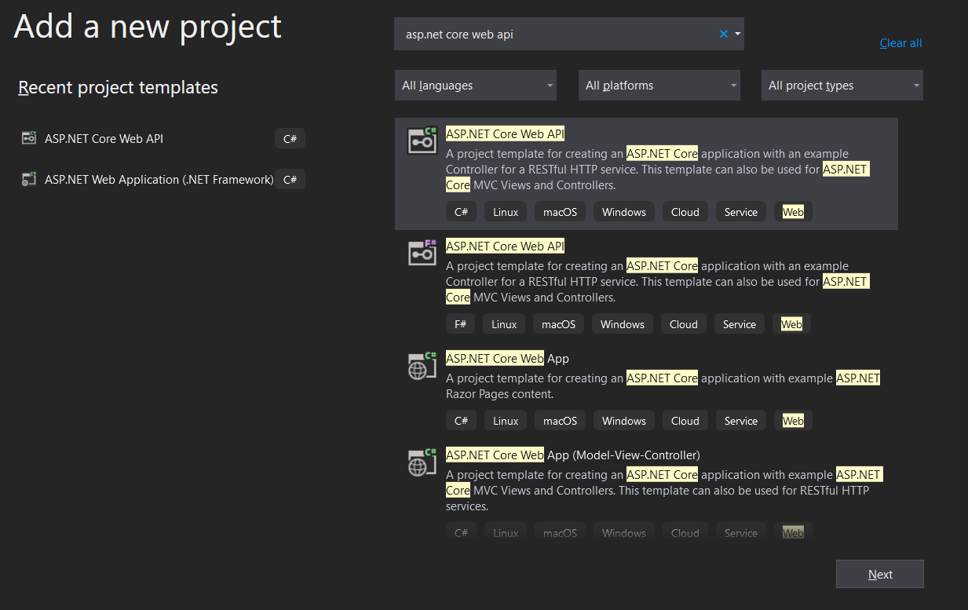

1. Provide the project name as StudentAttendanceManagement and click on the Next button

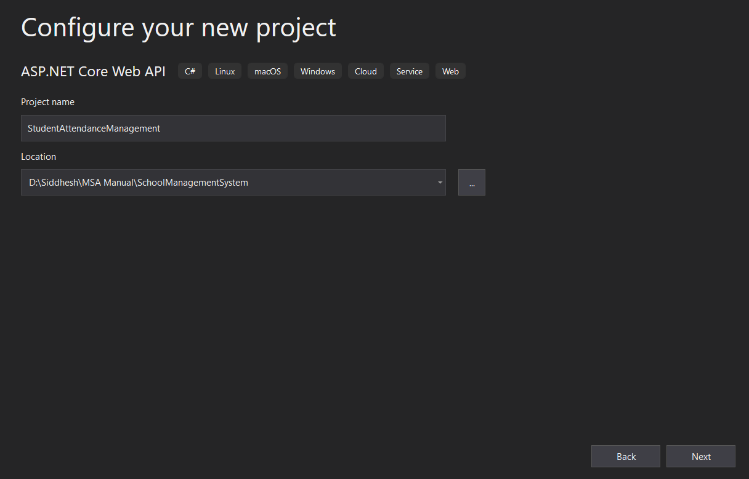

1. Select .NET Core 3.1 as Framework

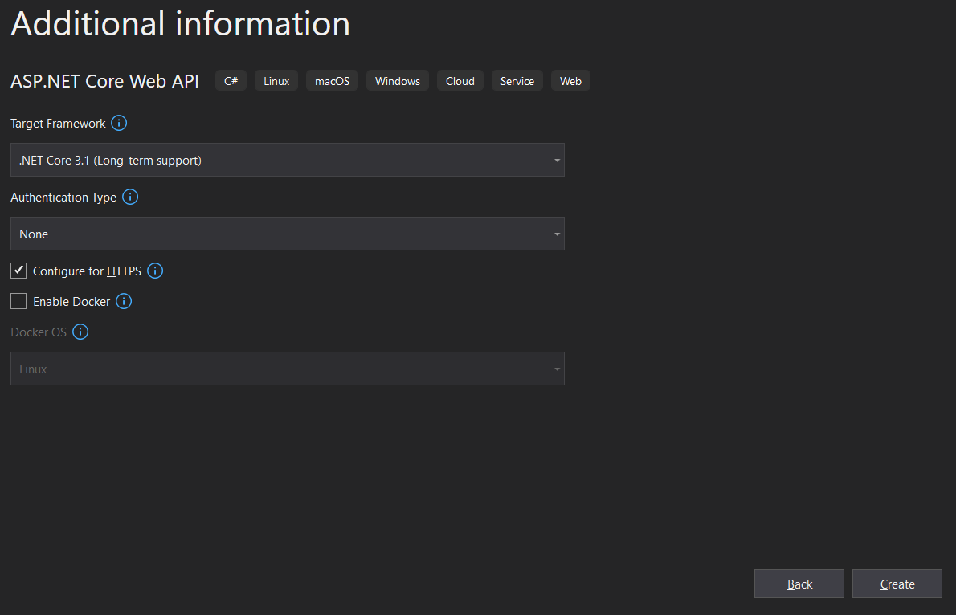

1. Once you click on the Create button, then it will add the new project to the existing solution. Now, our solution containing two projects with the following file and folder structure.

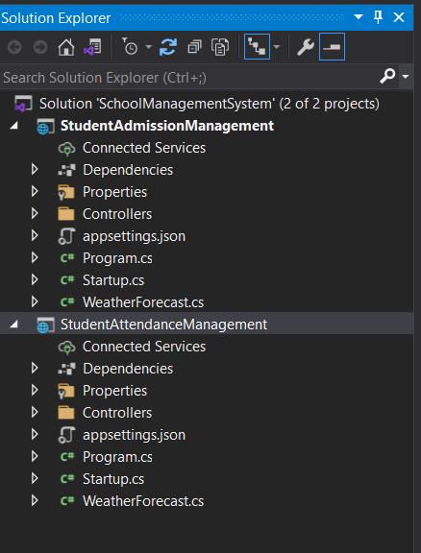

Now we have two microservices defined one for Student Admission purposes and the other for Student Attendance purposes.

**Creating Models:**

Now let’s create a model class to hold details of Admission and Attendance in both the projects respectively

1. So, right-click on the StudentAdmissionManagement project and add a class file with the name StudentAdmissionDetailsModel.cs and then copy and paste the following code in it.

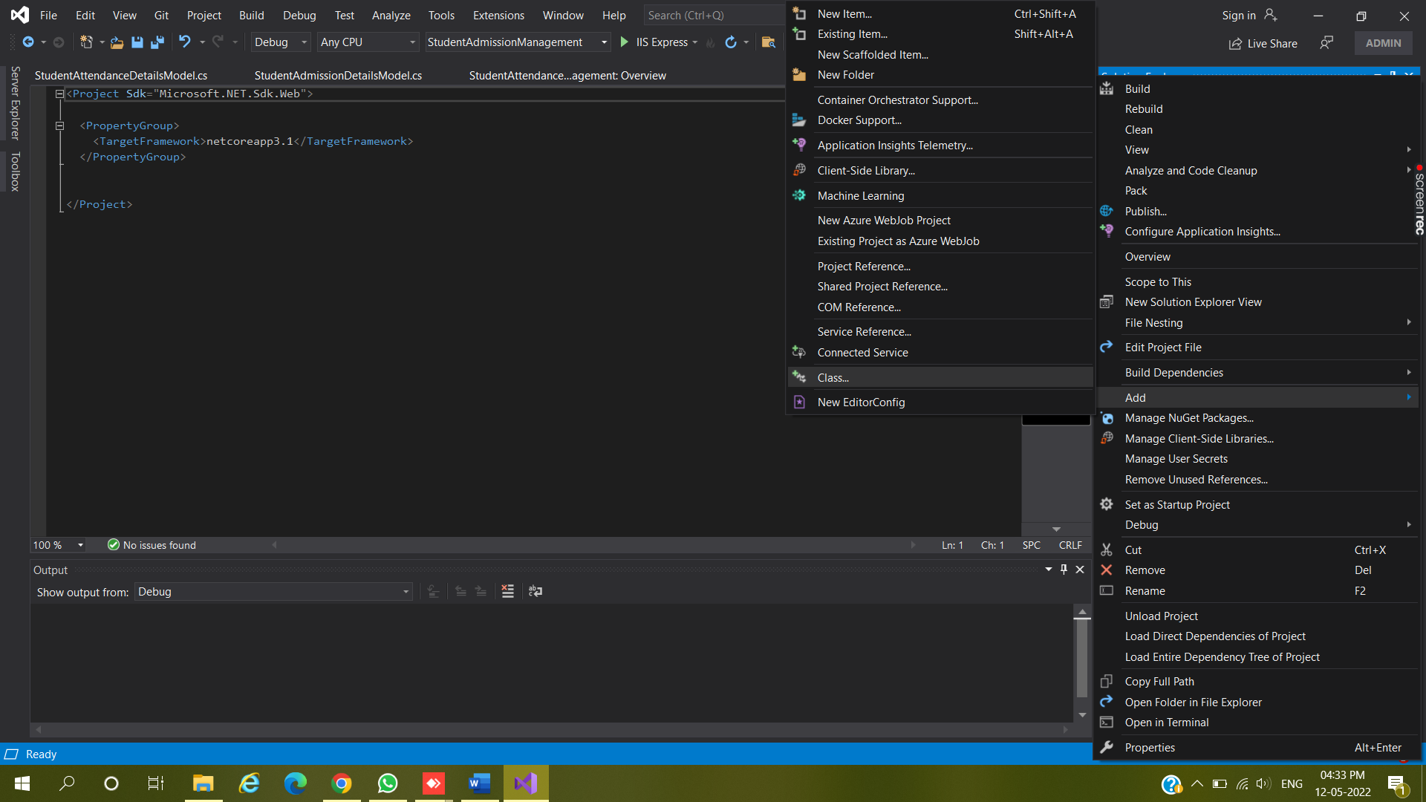

1. Edit the codes of Class Files according to the Code Given below

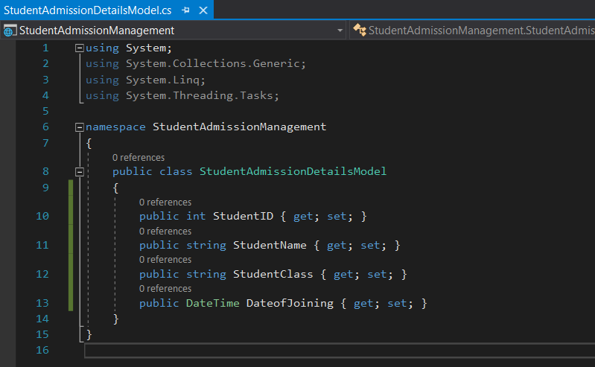

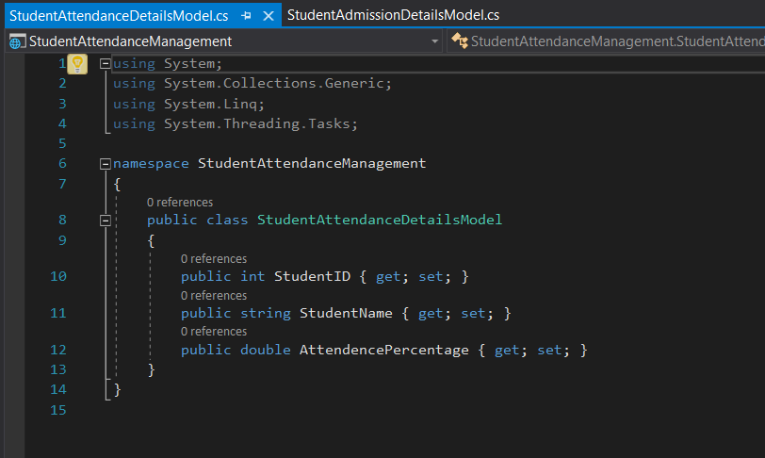

##### **Creating Controllers:**

1. Right-click on the Controllers folder of StudentAdmissionManagement and then select Add => Controller option from the context menu as shown in the below image.

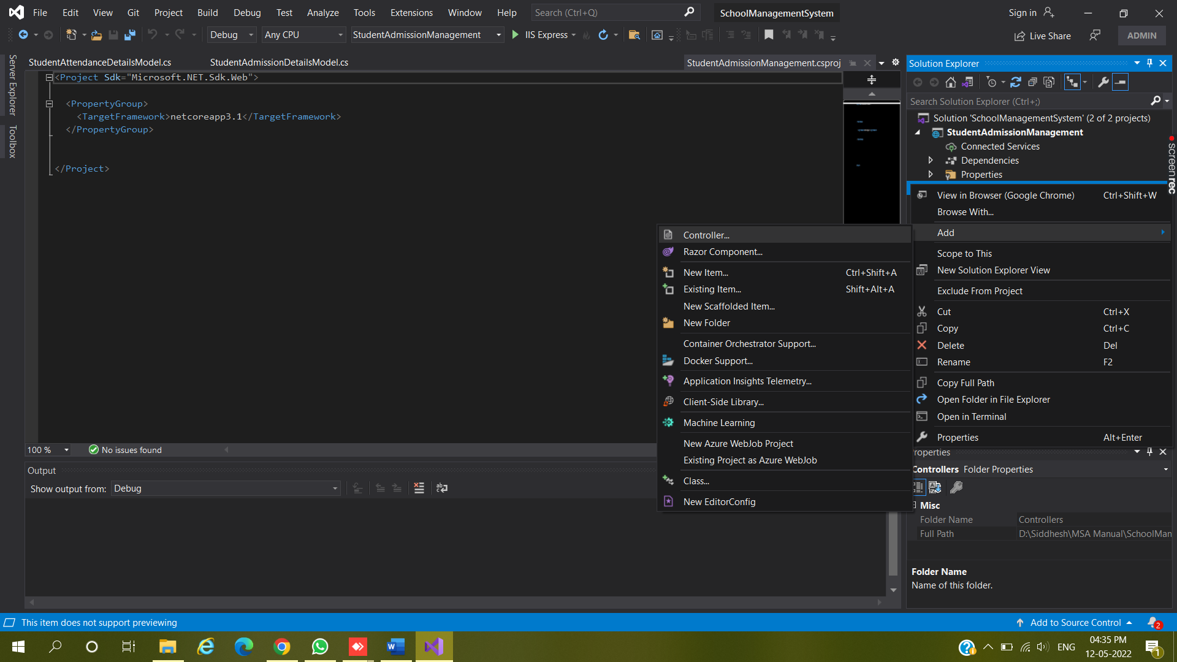

1. Once you select the Add => Controller option, then it will open the Add New Scaffolded Item window. Here, first, select the API template and then select the Add Controller with read/write action template and click on the Add button

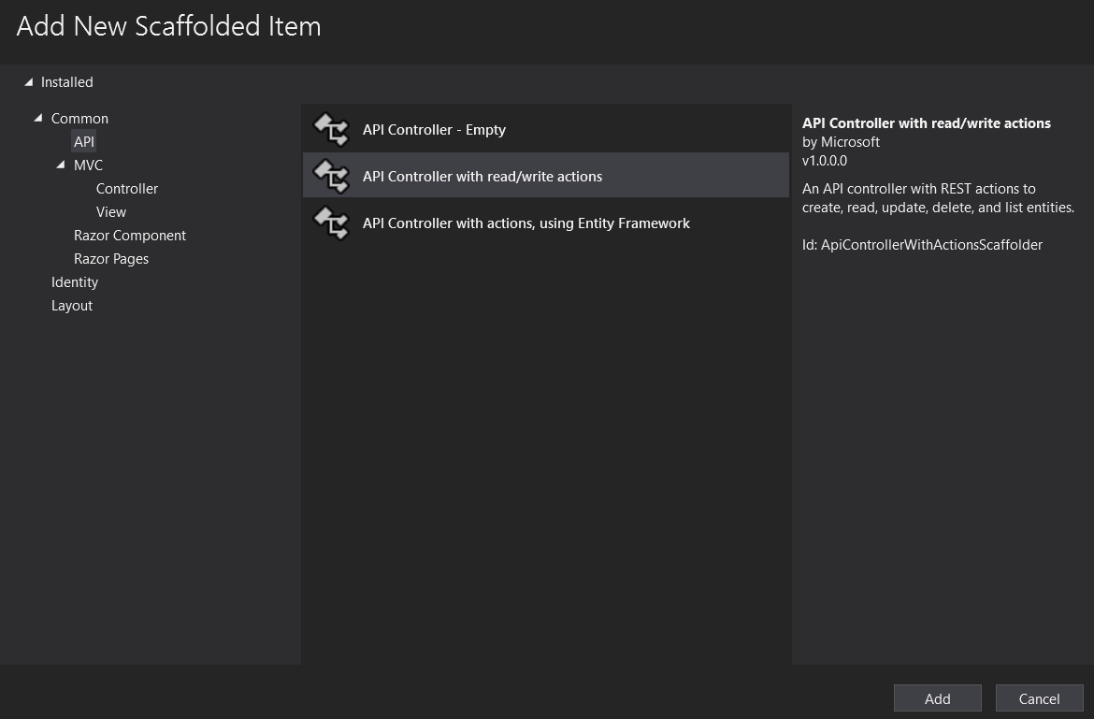

1. Provide the name for your Controller class and click on add button

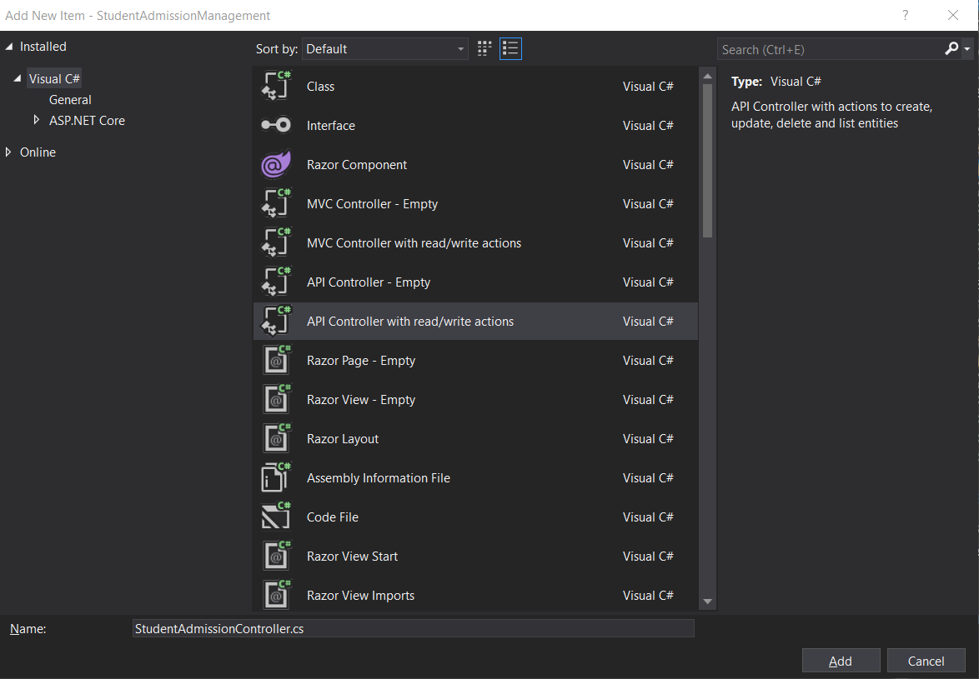

1. Once you click on the Add button, then it will add the StudentAdmissionController within the Controllers folder of your StudentAdmissionManagement project.

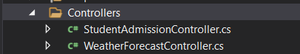

1. Edit the code of your Controller class accordind to the given code

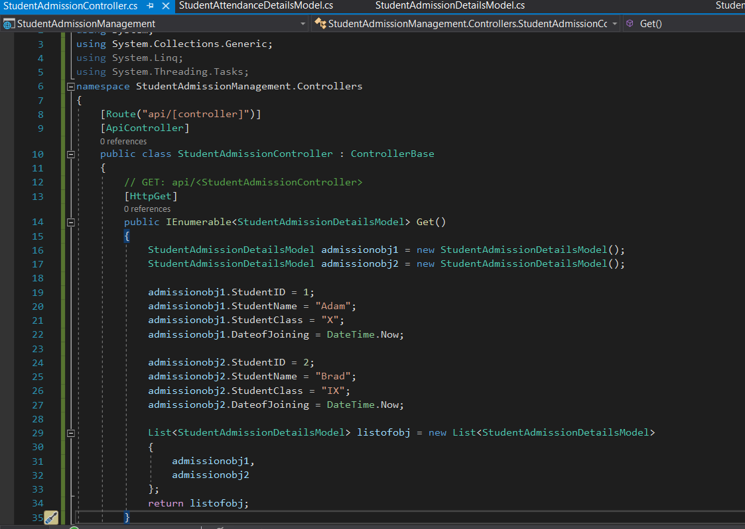

1. Now, Right-click on the Controllers folder of StudentAttendanceManagement and then select Add => Controller option from the context menu

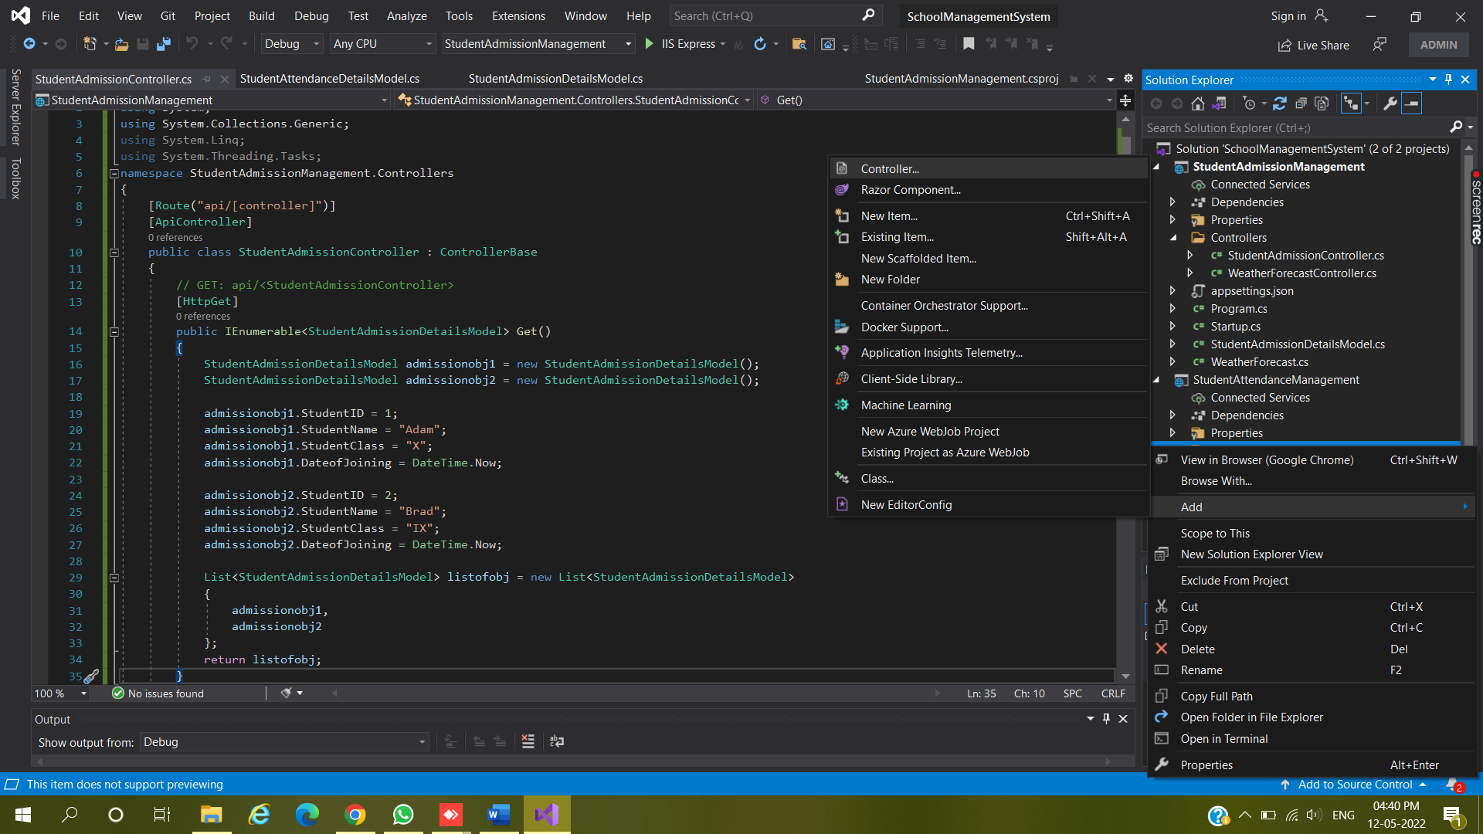

1. Select the API template and then select the Add Controller with read/write actions and click on the Add button

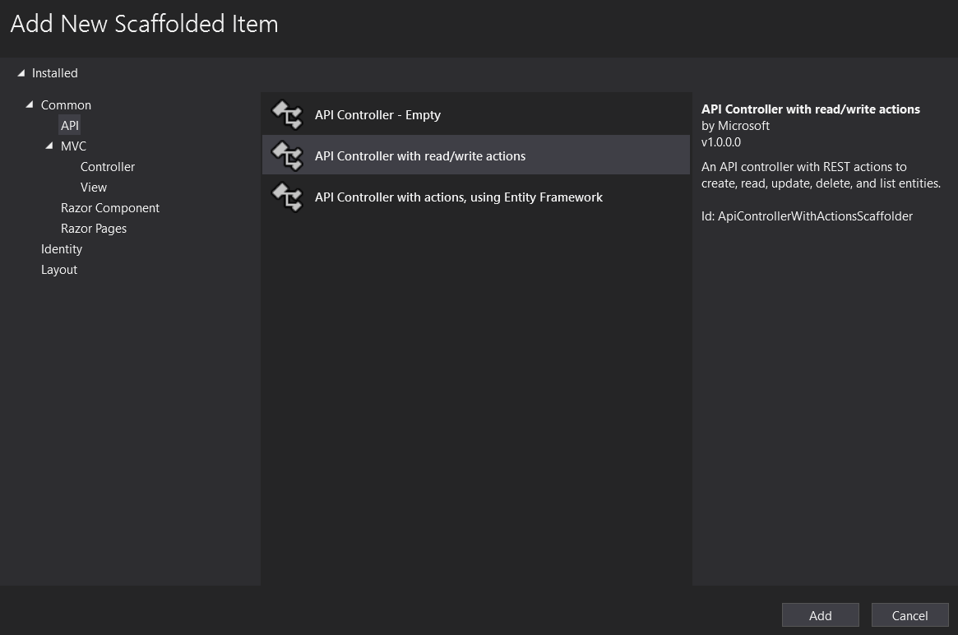

1. Provide the name for your Controller class and Click on Add

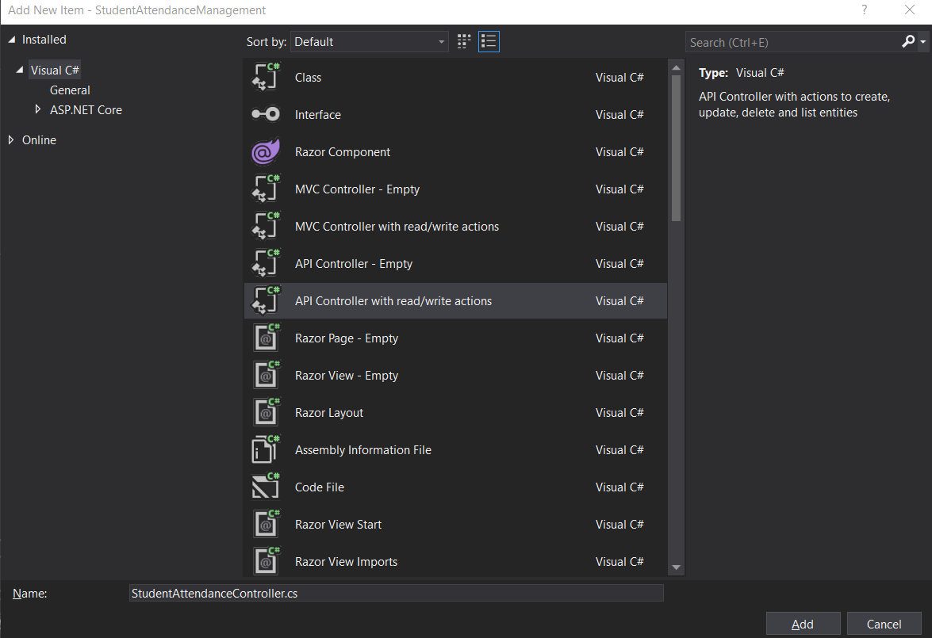

1. Once you click on the Add button, then it will add the StudentAttendanceController within the Controllers folder of your StudentAttendanceManagement project.

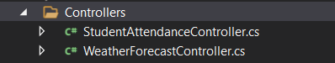

1. Edit the code of Controller according to the Code given below

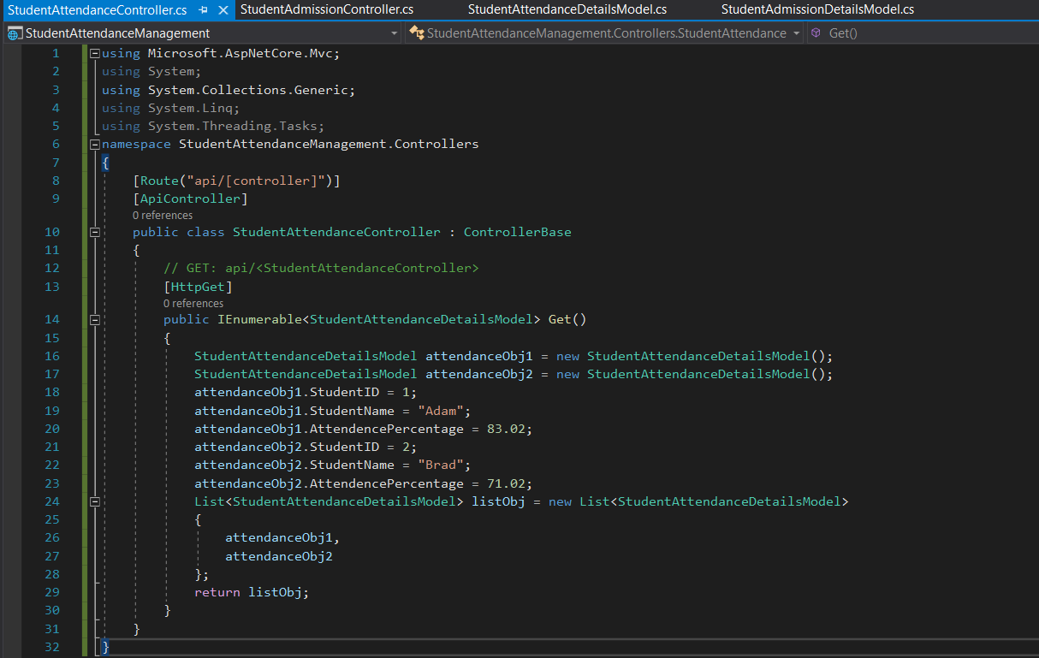

1. Let’s build the solution and launch both the Web API services (Microservices) simultaneously. For this, we have to set both the projects as starting projects. For that, open the properties window of Solution and then select multiple startup projects radio button and set the action to start for both the projects as shown in the below image.

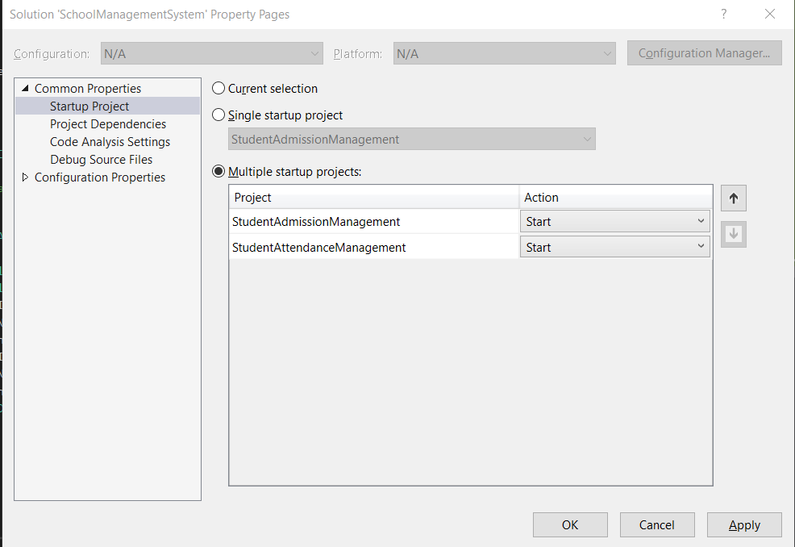

1. Edit the LaunchUrl part of the launchSettings.json file from “Deafault” to “api/StudentAdmission”

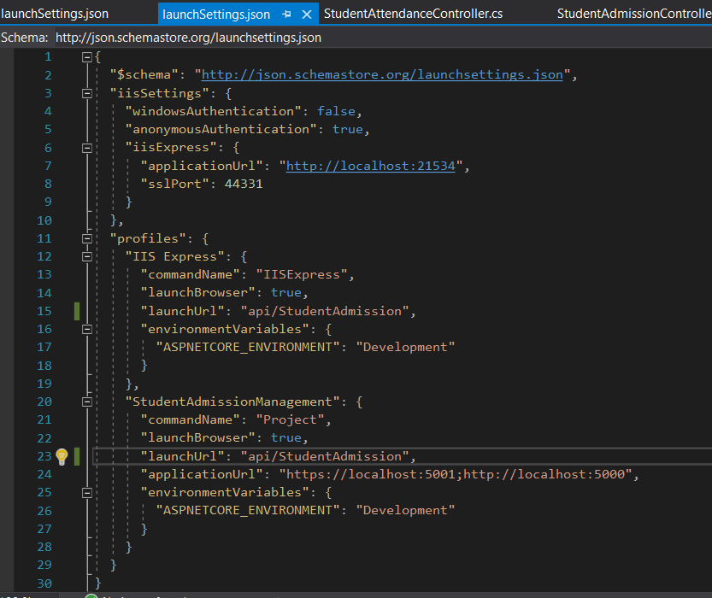

1. Edit the LaunchUrl part of the launchSettings.json file from “Deafault” to “api/StudentAttendance”

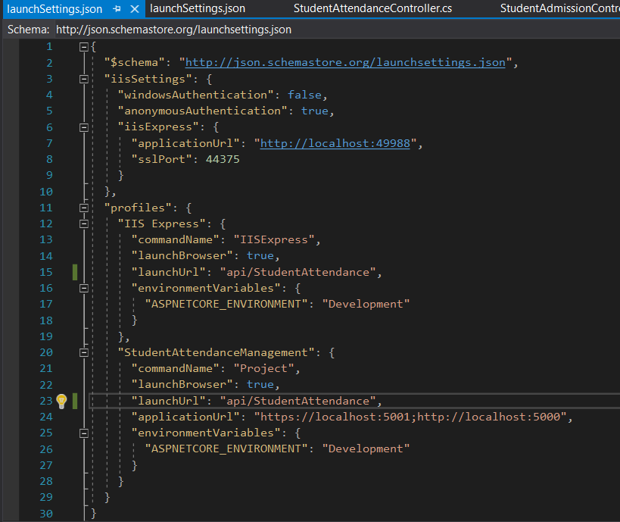

##### **Running Applications and Showing Outputs**

Click on the Start button and then we get two browsers opened and point to the controllers from browsers like below. Browser by default sends GET HTTP Verb.

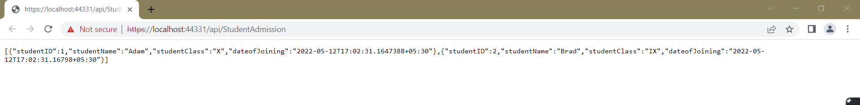

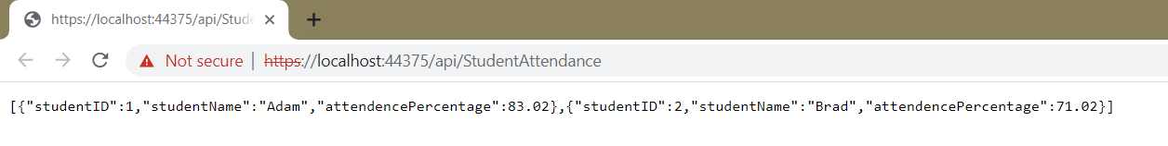

**Practical No : 8**

**Working with Kubernetes**

Prerequisites

Download and install Docker Desktop as described in Orientation and setup.

Describing apps using Kubernetes YAML

1. You already wrote a very basic Kubernetes YAML file in the Orchestration overview part of this tutorial. Now, let’s write a slightly more sophisticated YAML file to run and manage our bulletin board. Place the following in a file called **bb.yaml:**

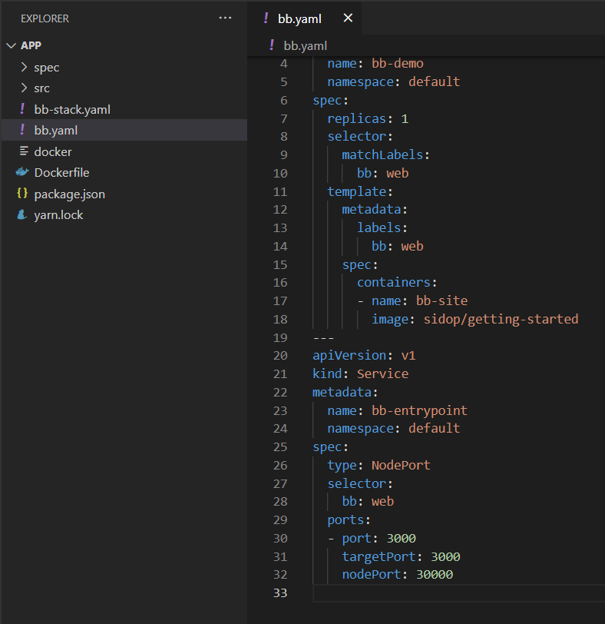

**Deploy and check your application**

2. In a terminal, navigate to where you created bb.yaml and deploy your application to Kubernetes:

**Docker tag getting-started sidop/getting-started**



**kubectl apply -fbb.yaml**

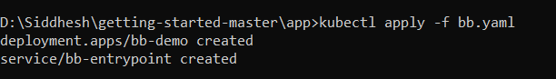

3. Make sure everything worked by listing your deployments:

**kubectl get deployments**

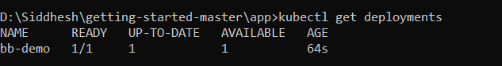

4. You can see the list of your deployment pod:

Kubectl describe pod

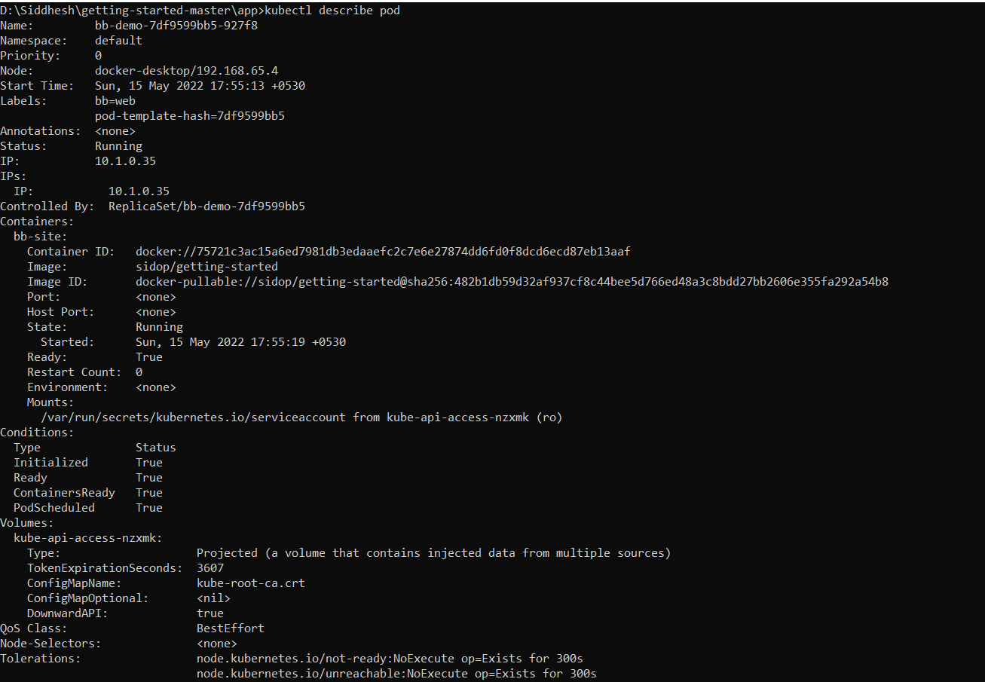

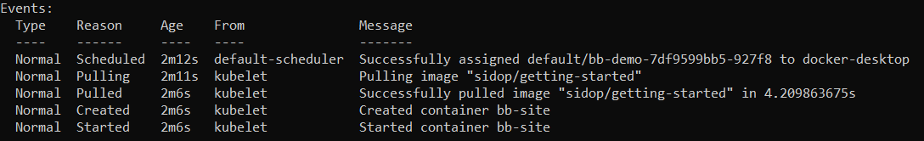

4. In addition to the default kubernetes service, we see our bb-entrypoint service, accepting traffic on port 30001/TCP.

**Kubectl get services**

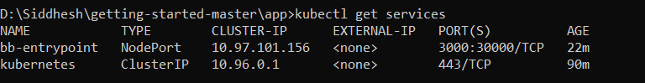

5. Open a browser and visit your bulletin board at localhost:30001; you should see your bulletin board, the same as when we ran it as a stand-alone container in container Docker images and container section of this file.

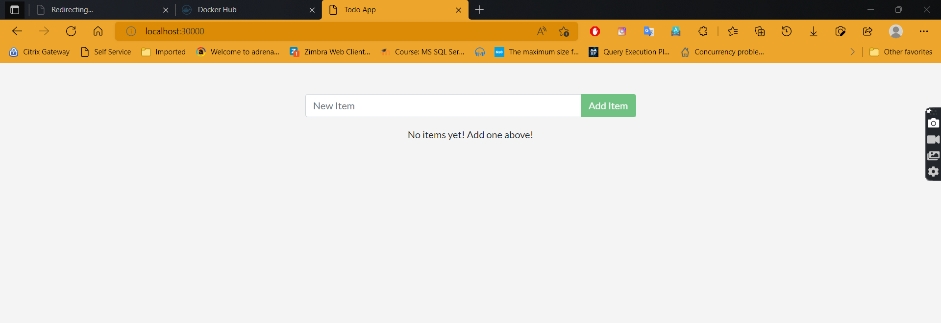

**Practical No : 9**

**Create a backing Service using ASP .NET**

**Download the RabbitMQ Server :**

[**https://www.rabbitmq.com/install-windows.html**](https://www.rabbitmq.com/install-windows.html)

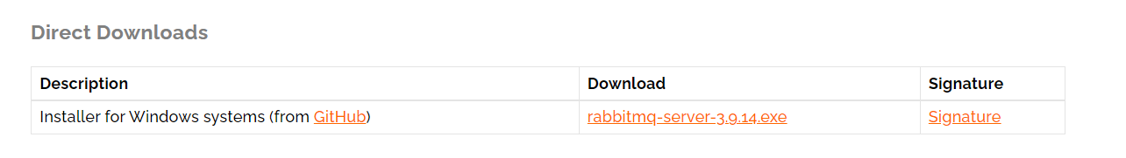

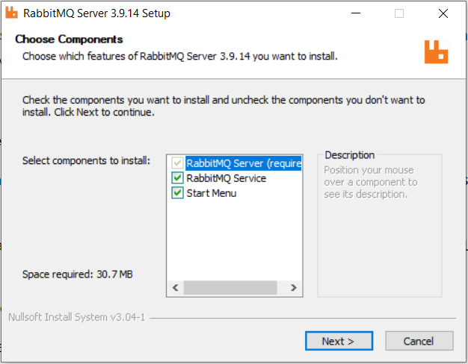

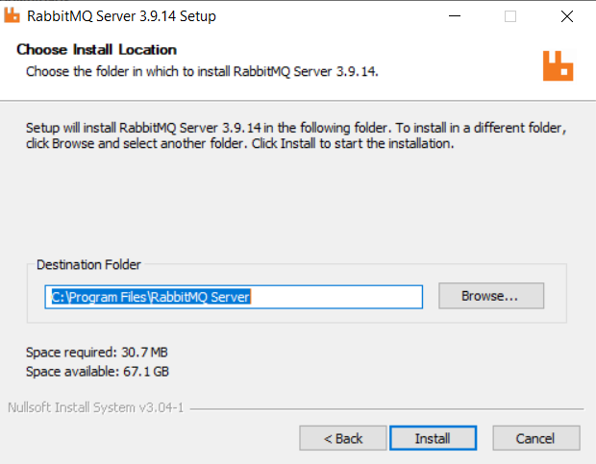

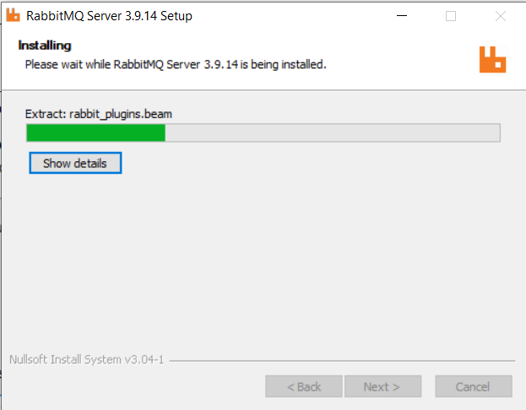

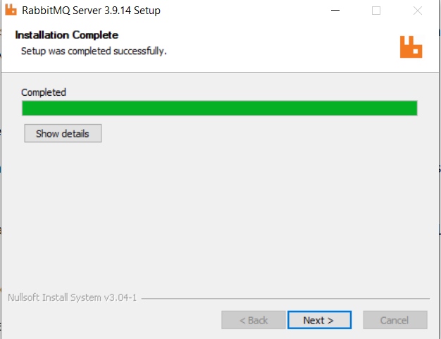

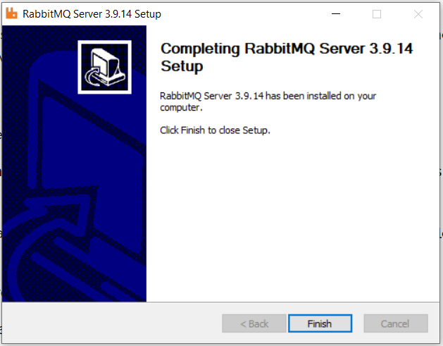

**Now Download the Ireland : Clock on Download Windows installer**

[**https://www.erlang.org/downloads**](https://www.erlang.org/downloads)

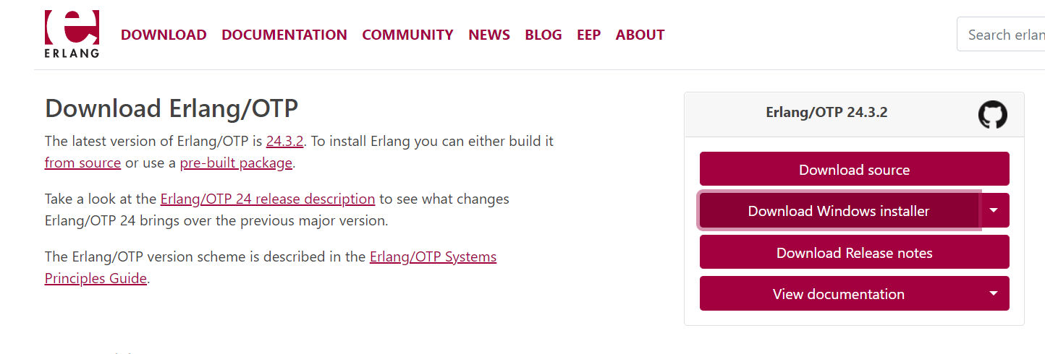

After download choose the component & click on next.

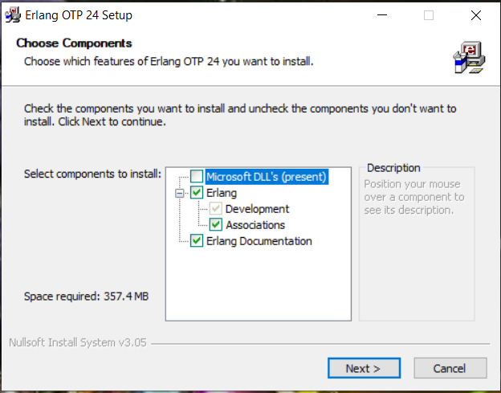

Choose the Install location where you want to install the Erlang OTP

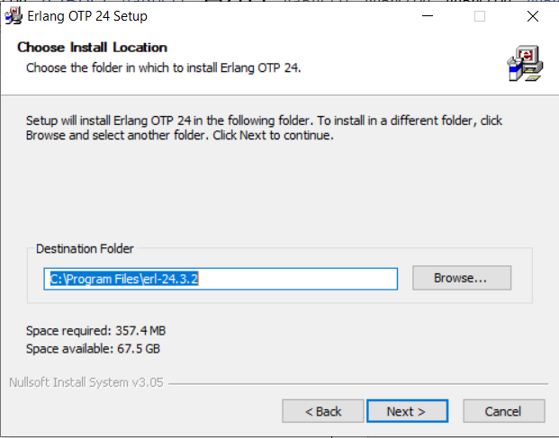

Now choose the start menu folder

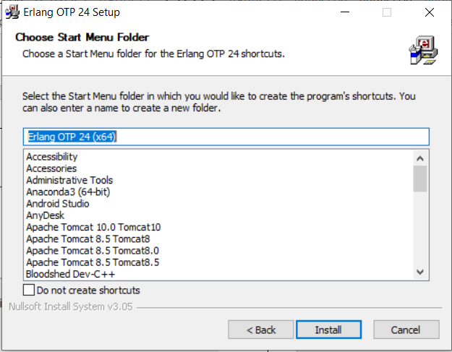

Wait until while Erlang get install and then click on close.

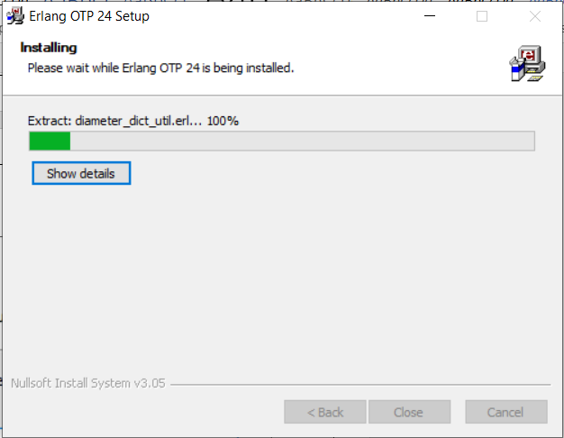

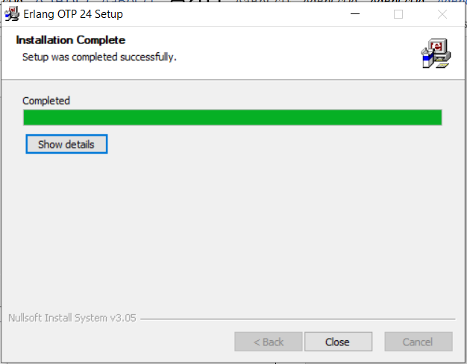

**Follow the stpes :-**

1. Run rabbitmq sbin as administrator

Type : rabbitmq-server start



2. Open Google Cgrome browser

Type in search bar : http://localhost:15672

Username : guest Password:guest



3. Press Login button

4. Open 5 Command Prompts : Run all as Administrator

5. Command Prompt 1 : Run TeamService on port 5001

Type :

D:

Cd StatlerWaldorfCorp.TeamService

dotnet run - - server.urls=http://0.0.0.0:5001



6. Command Prompt 2 : Run Location Reporter on port 5002

Type :

D:

Cd StatlerWaldorfCorp.LocationReporter

dotnet run - - server.urls=http://0.0.0.0:5002



7. Command Prompt 3 : Run EventProcessor on port 5003

Type :

D:

Cd StatlerWaldorfCorp.EventProcessor

dotnet run - - server.urls=http://0.0.0.0:5003



8. Command Prompt 4 : Run RealityService on port 5004

Type :

D:

Cd StatlerWaldorfCorp.RealityService

dotnet run - - server.urls=http://0.0.0.0:5004



9. Command Prompt 5 : For curl commands

10. Create a Team using TeamService running on port 5001

curl -H "Content-Type:application/json" -X POST -d "{\"id\":\"aaaaaaaa-bbbb-bbbb-bbbb-cccccccccccc\",\"name\":\"Kimberly Team\"}" <http://localhost:5001/teams>

11. Add a member to the team

curl -H "Content-Type:application/json" -X POST -d "{\"id\":\"aaaaaaaa-bbbb-bbbb-bbbb-cccccccccc21\",\"firstName\":\"Kimberly\",\"lastName\":\"Moniz\"}" <http://localhost:5001/teams/aaaaaaaa-bbbb-bbbb-bbbb-cccccccccccc/members>



12. Add location for member

curl --insecure -H "Content-Type:application/json" -X POST -d "{\"reportid\":\"aaaaaaaa-4444-4444-4444-cccccccccc21\",\"origin\":\"Mumbai\",\"latitude\":12.5,\"longitude\":12.5,\"memberId\":\"aaaaaaaa-bbbb-bbbb-bbbb-cccccccccc21\"}" http://localhost:5002/api/members/aaaaaaaa-bbbb-bbbb-bbbb-cccccccccc21/locationreports



13. Check location reporter cmd



14. Check event processor cmd

****